**HE3022 – Econometric Modeling & Forecasting**

**Final Report AY19/20 Sem 2**

**Submitted by:**

**Melissa Tan**

**Christopher Mok**

**Feng Zhiyang**

**CONTENTS**

1. Introduction

* Introduction to FSI
* Importance of forecasts

1. Preliminary Investigation

* Identification of Training & Test sets
* Plots of FSI
* Decomposition

1. Establishing a Benchmark Model

* Comparing snaive, ses, hw & stl-naive forecasts

1. ETS vs ARIMA

* ETS & STL-ETS models
* ARIMA models
* STL-ARIMA models

1. Regression

* Multiple Regression Model
* Dynamic Regression Model

1. Model Selection & Forecasting

* Combination Models
* Selection of Model
* Ex-ante forecasts
* Scenario forecasts

1. Conclusion

**SECTION 1 :** INTRODUCTION

The F&B sector is vital to Singapore’s economy. The estimated value of F&B sales is around $8.4b a year. It also contributed to 6% of total employment in 2019 (MOM, 2020). F&B players are operating in an increasingly competitive environment, with cost challenges especially in rental and labour. Rental costs, especially in malls, are expected to be higher as property supply is expected to fall from 2020 onwards. Moreover, the tightening of foreign labour dependency ratio also has a negative impact on F&B businesses, which are highly labour dependent. Digitisation and food delivery apps such as GrabFood, Foodpanda & Deliveroo have come onstream in recent years, and while they help owners reach out to more customers, the average commission is around 25%, which contributes to rising costs (Yeo & Tan, 2019).

With the importance of the F&B sector in Singapore’s economy, its forecast helps policymakers to track the consumer’s spending patterns and intervene the market to provide a safety net to the workers if necessary. The monthly forecast takes the monthly seasonality into account and reflects the overall demand in the F&B sector which helps F&B managers and other relevant stakeholders to better manage their short-term staffing and supply orders. Thus, our group aims to forecast the Food & Beverage Services (FSI) index over the next 12 months, from March 2020 - February 2021[1].

The dataset that we are using in this forecast is the “Food & Beverage Services Index, (2017 = 100), At Current Prices, Monthly”. The index (FSI) measures the short-term performance of the Food & Beverage (F&B) services industries based on the sales records of F&B services establishments. The sales figure refers to the value of F&B sold to consumers, excluding Goods & Services Tax (GST). It covers F&B sales of all F&B establishments regardless of the modes of sales transactions (including those transacted via food delivery platforms). Here, F&B refers to 4 industries - Restaurants, Fast Food Outlets, Food Caterers & Cafes, Food Courts & Other Eating Places. This index does not include hawker centres. The weightage of each component is as follows :

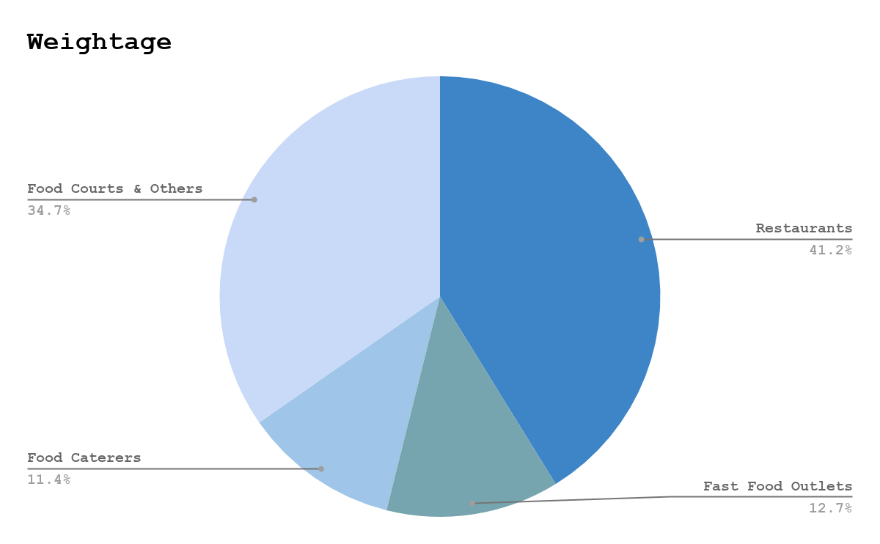

***Fig 1.1 Weightage of FSI***

**SECTION 2 :**

PRELIMINARY INVESTIGATION

Firstly, we looked at the initial dataset, which had data from 1985-2020. Due to the emergence of food catering data from 2005, we have selected our dataset from 2005/01 onwards and plotted it in Fig 2.1. In this report, we will compare various models to fit the data using a training set consisting of 144 observations (Jan 2005 – Dec 2016) and forecast for 36 observations (Jan 2017 – Dec 2019). To evaluate our models, we use the training set for forecasting and evaluate it against the test set using RMSE as the criterion. The model with the lowest RMSE in the test set is considered the ‘best’ model.

Although the FSI values have been updated to 2020/2, we have decided to exclude observations in 2020 from our test set as some data for predictor variables in Section 6 are only available until 2019/12. Also, the onset of COVID19 in 2020 leads to an outlier observation which might affect the evaluation of the model. The restriction of our test set ensures that all the candidate models discussed in subsequent sections have identical test sets so that they can be evaluated fairly.

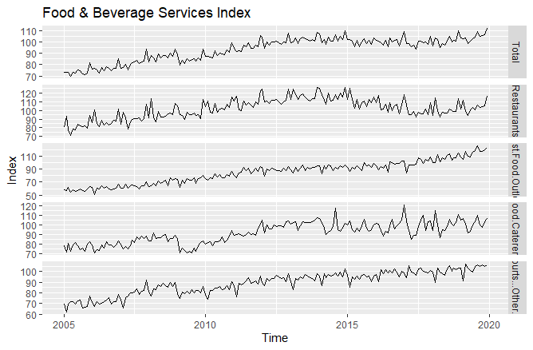

***Fig 2.1 Plot of FSI Components***

Looking at the overall plot, we observe a generally increasing trend until 2015, apart from the 2008-09 Financial crisis. Then, it began to show a decreasing trend. However, after 2017, the index seems to be on an increasing trend again. The possible reasons for each of the changes are explored below :

1. 2015-2017

>Reduction of Dependency Ratio Ceiling to 45% on 1 July 2014 (MOM, 2014; Singapore Budget 2014)- tight labour supply, which is felt more keenly by labour intensive industries like F&B, placing upward pressure on wages and hence costs.

1. 2017-2020

>SG Economy grew 3.6% in 2017, trade reverses decline - strong growth in the manufacturing and services sectors

>Effects of operation restructuring and streamlining processes begin to be seen - productivity growth.

**Time Series Decomposition**

To overcome the limitations of classical decomposition, we use STL to decompose the time series and allow the seasonality component to change over time by specifying s.window=13. From the decomposition, we observe a consistent seasonality and a generally increasing trend. Given the constant seasonality, our group has decided not to further transform the dataset.

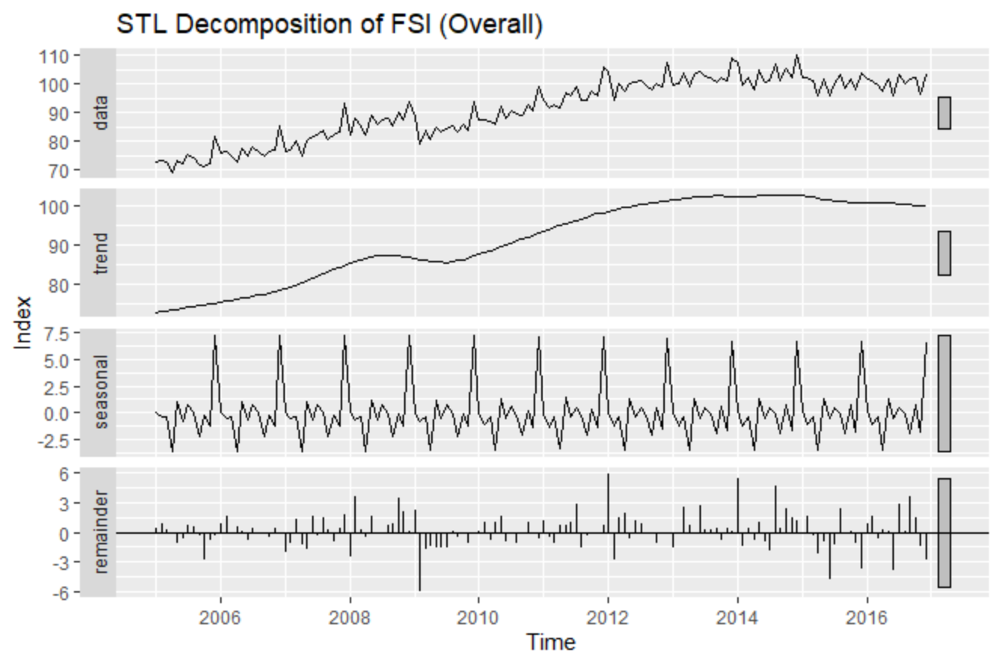

***Fig 2.2 STL Plots***

As observed by the lag plot, the strong persistent correlation with its lags confirms the presence of a trend.

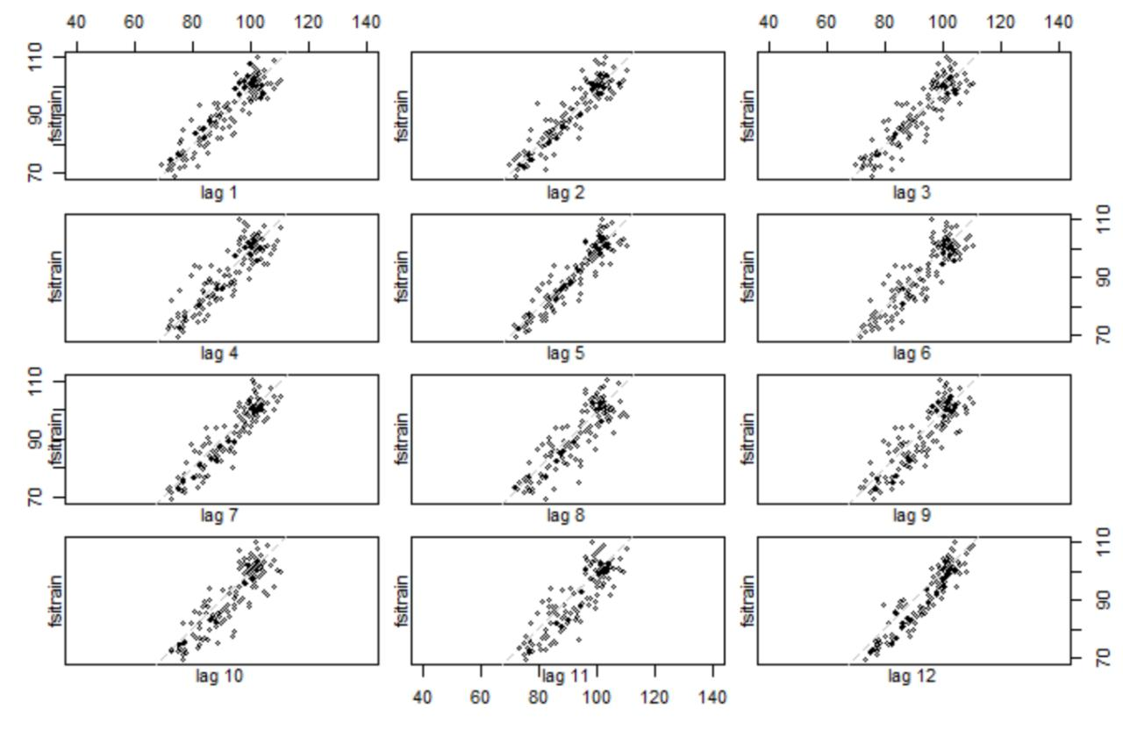

***Fig 2.3 Lag Plots***

Next, we will be looking at the seasonal plots of the FSI (Fig 2.4 & 2.5). Here, we observe that sales are the lowest in April & highest in Dec. To get a clearer idea of the reasons for this seasonality, we look at the components individually (Figs 2.6-2.9).

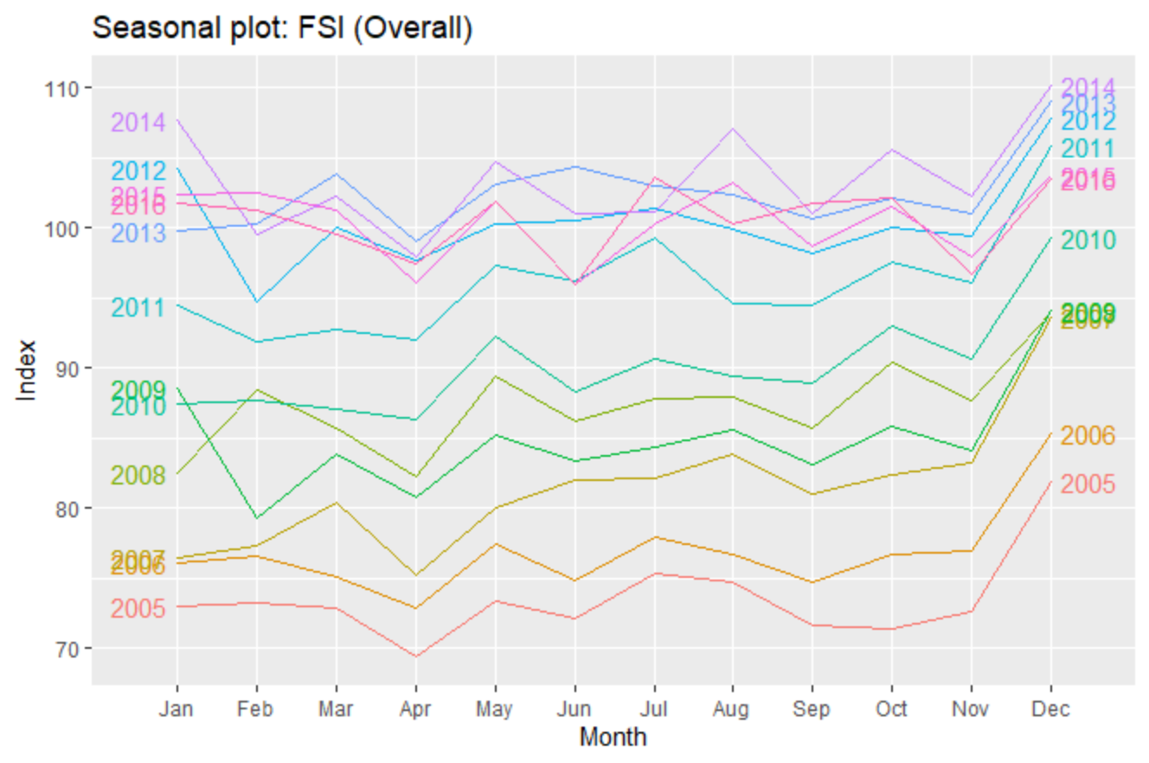

***Fig 2.4 Seasonal Plots of FSI (Overall)***

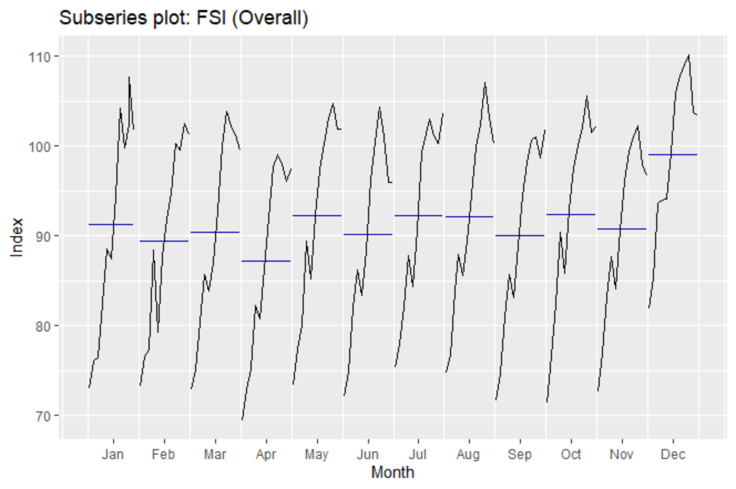

***Fig 2.5 Subseries Plots of FSI (Overall)***

**Restaurant**

The seasonal plot for the restaurant component is highly similar to the total, with the highest sales in December & the lowest volume in April. With a high weightage of 41.2% in calculating the total index, it is no surprise that the restaurant component contributes significantly to the seasonality observed in the FSI (Overall) plot.

**Fast Food**

Similarly, it is the highest in December. However, we notice that the lowest value occurs in February. This could be because of Chinese New Year, where many Chinese families (Making up more than 75% of Singapore’s population) stay at home or eat at restaurants for celebrations and reunion meals.

**Catering**

The highest sales for catering are in December, and the lowest in April, corresponding to the patterns observed in the overall plot. However, we also see a significant increase in volume in Aug, that is not observed in the other plots. This could be due to Hari Raya Haji celebrations as well as mass University Orientation Activities.

**Others**

We can observe a significant increase in sales in December for others. However, in this plot, we can also see a significant decrease in volume during February. Similarly, this could be because of Chinese New Year.

**Overall Comments**

In general, the sales are high in December. In February, the sales for Restaurants is very high, while the converse is true for Others and Fast Food Outlets. This suggests that they are substitutes. A possible reason could be due to the Chinese New Year celebrations. Since the weightage of restaurants (41.2%) and the other 2 components (Fast Food : 12.7%; Others : 34.7%), which adds up to 47.4% are roughly similar, they likely offset each other, leading to the seasonality for the overall index in February to be masked.

For the following discussion, we will be focusing on the overall component of FSI.

***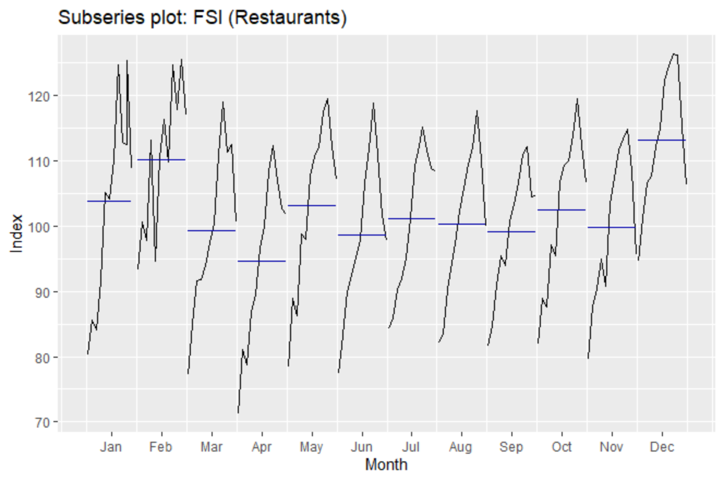****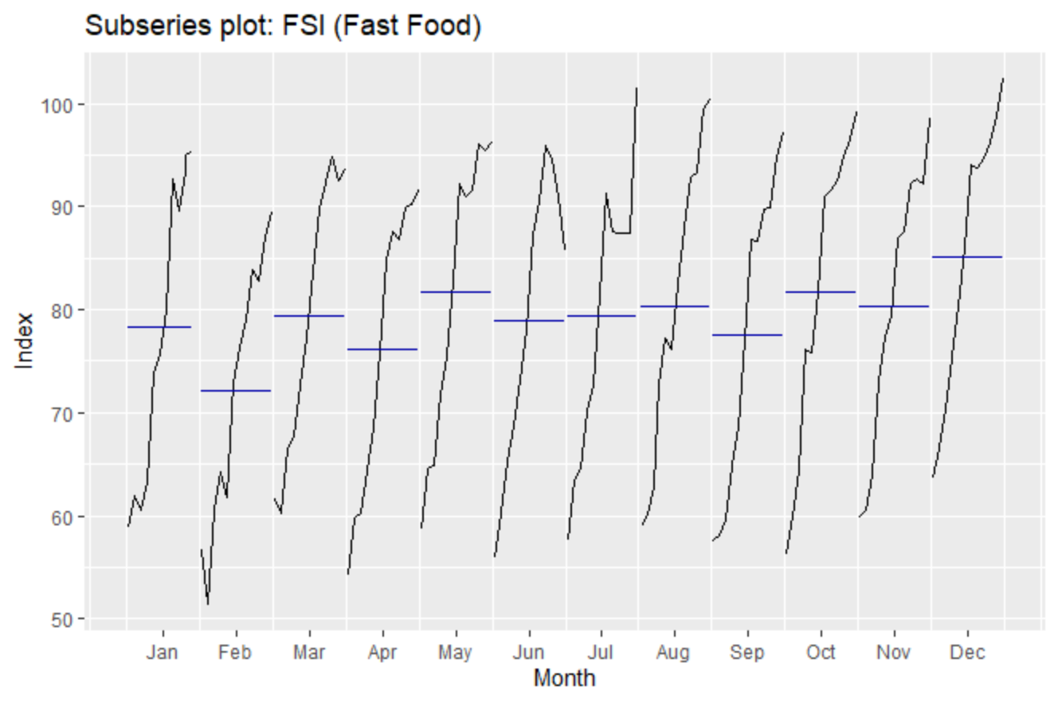*

***Fig 2.6 Subseries Plot of FSI (Restaurant) Fig 2.7 Subseries Plot of FSI (Fast Food)***

***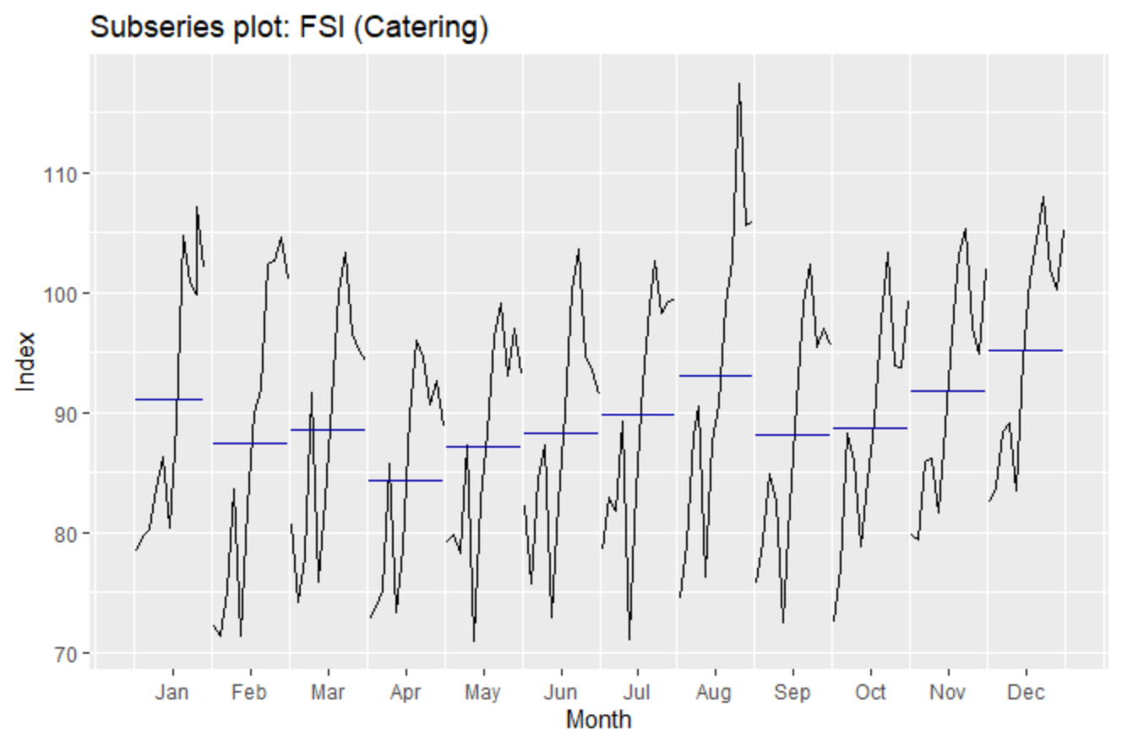****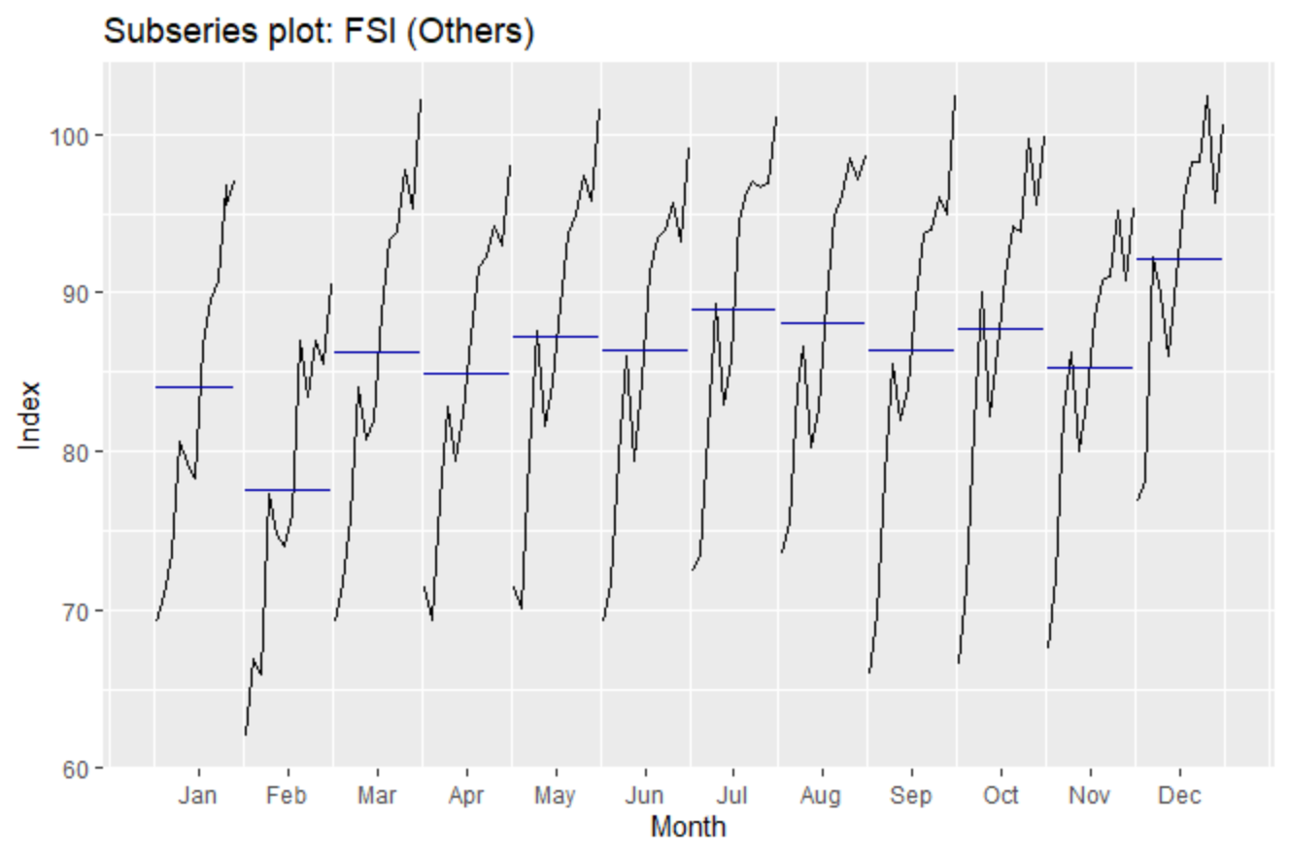*

***Fig 2.8 Subseries Plot of FSI (Catering) Fig 2.9 Subseries Plot of FSI (Others)***

**SECTION 3 :** ESTABLISHING A BENCHMARK MODEL

In this section, we will be considering the following models :

1. **Seasonal Naive Method**

Forecast set to be the last observed value from the same season of the year.

1. **Simple Exponential Smoothing**

Weighted average of past observations, with the weights decaying exponentially

1. **Holt-Winters Additive**

Constant seasonal variation.

1. **Holt-Winters Multiplicative hw**

Seasonal variation changes proportionally to level of series.

1. **STLF (Naïve)**

Naive forecasts of seasonally adjusted FSI, ‘reseasonalised’ by adding the seasonal component into the naïve forecast.

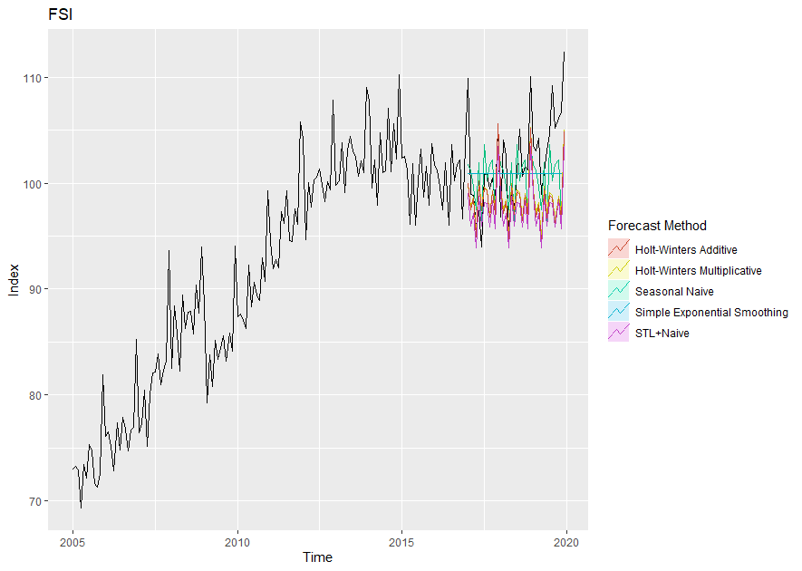

***Fig 3.1 Actual vs Fitted Data from different forecasting methods***



***Table 3.1 Forecast Errors***

We evaluate the models by comparing the forecast accuracy in the test set. The model with the lowest test-set error based on RMSE is the **seasonal naive method**. From the graph, it is evidently the one that fits better than the other methods as well. Hence, the seasonal naive method will be our benchmark model for our final selection of forecasting model.

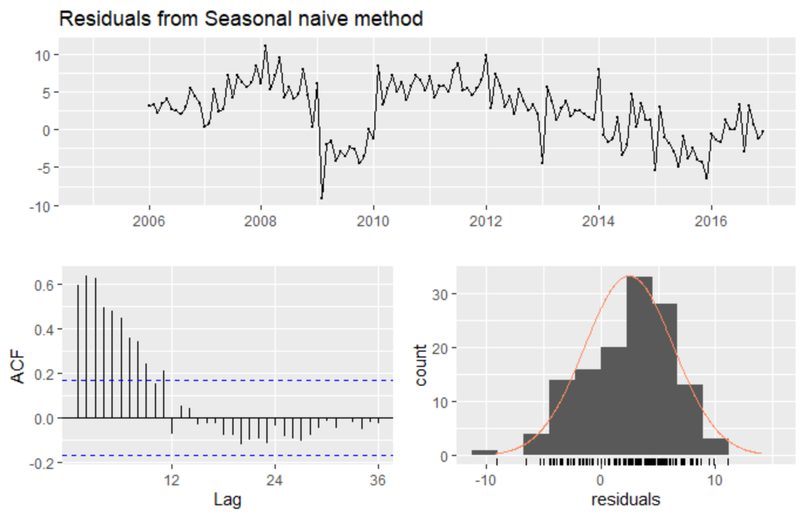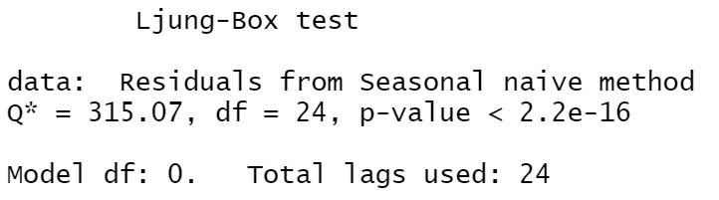

***Fig 3.2 Residuals of Seasonal Naive Method***

From the residual plot, we reject the null hypothesis of no autocorrelation at 5% level of significance as the p-value for Ljung Box test is extremely small. As the errors do not appear to be white noise, there is information left in the residuals which should be used to compute the forecast. Hence, we move on to consider other models.

**SECTION 4 :** ETS vs ARIMA

Next, we consider innovations state space models. First, we consider fitting an ETS model by using the ets() function. The summary of the result is displayed in Fig 4.1.

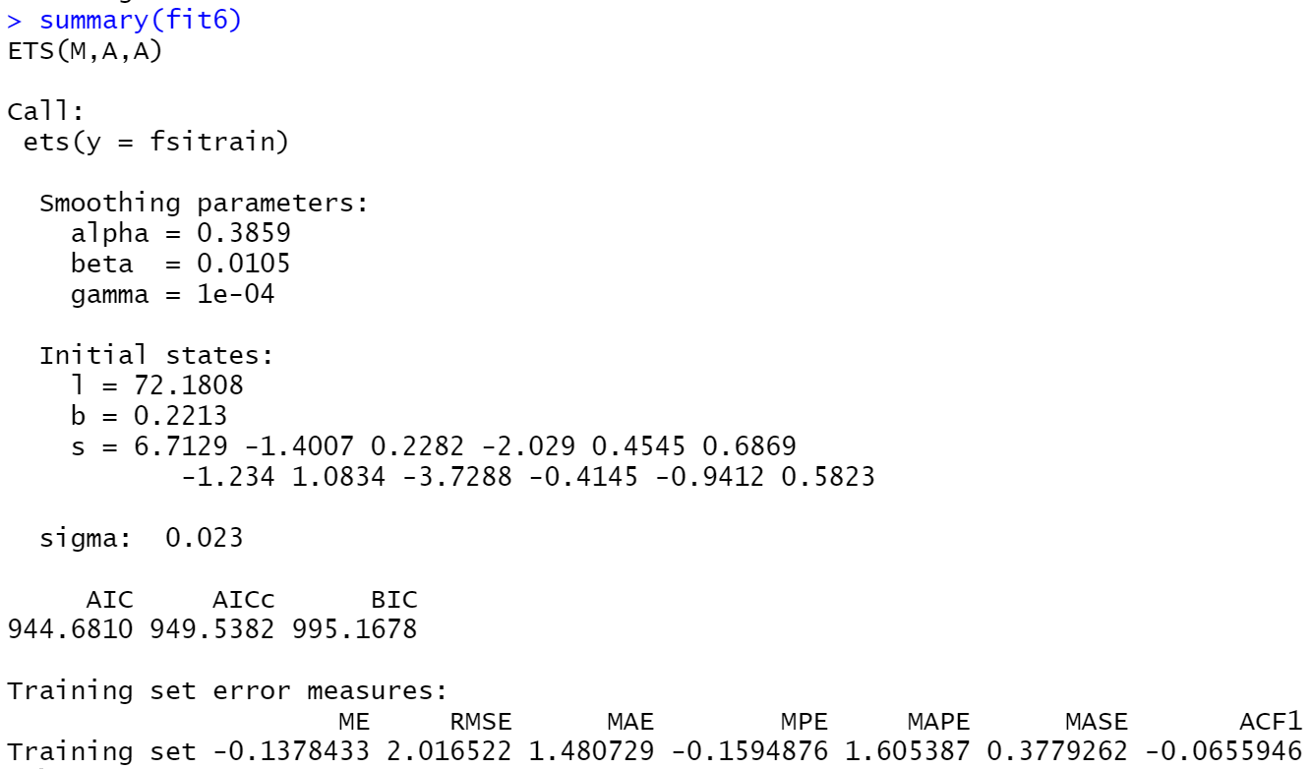

***Fig 4.1 Summary of ETS Model***

The respective measurement and transition equations of the model are as follows : $$y_{t}=\left(l_{t-1}+b_{t-1}+s_{t-12}\right)\left(1+ϵ_{t}\right)$$

$$l_{t}=l_{t-1}+b_{t-1}+0.386\left(l_{t-1}+b_{t-1}+s_{t-12}\right)ϵ_{t}$$

$$b_{t}=b_{t-1}+0.0105\left(l_{t-1}+b_{t-1}+s_{t-12}\right)ϵ_{t}$$

$$s_{t}=s_{t-12}+0.0001(l_{t-1}+b_{t-1}+s_{t-12})ϵ_{t}$$

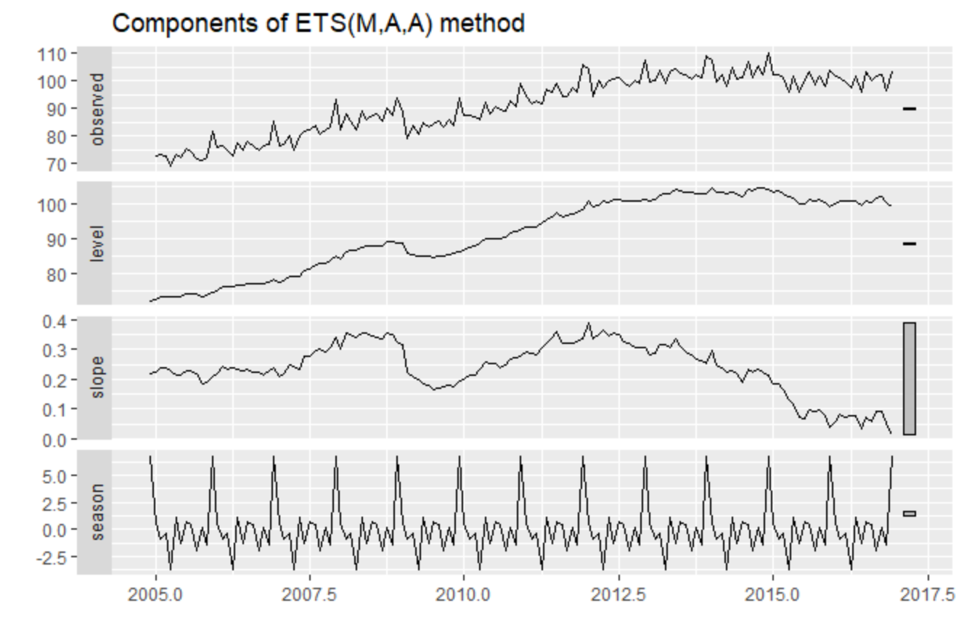

***Fig 4.2 ETS Components***

**STL+ETS**

We also consider STL+ETS forecasts. The ETS(M,A,N) model, also known as the Holt Linear method, is returned.

The point forecast & prediction interval of the following models are plotted.

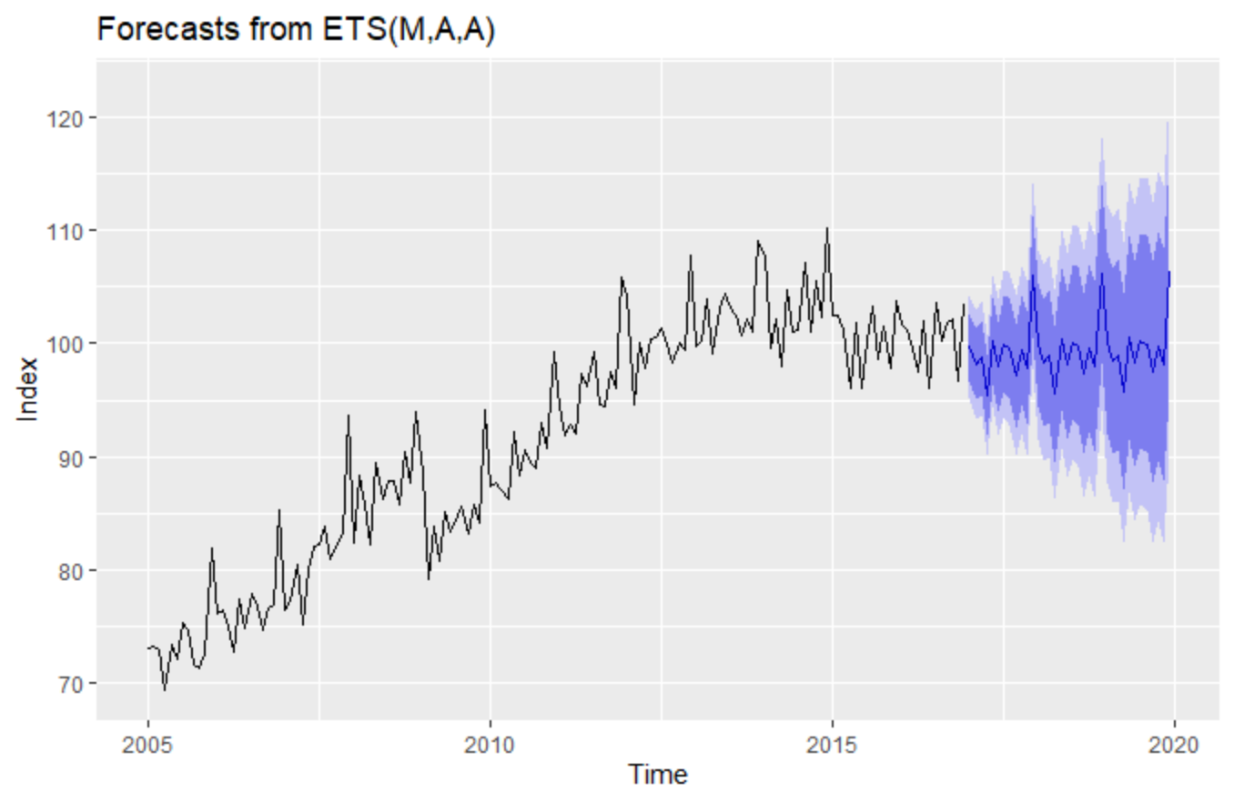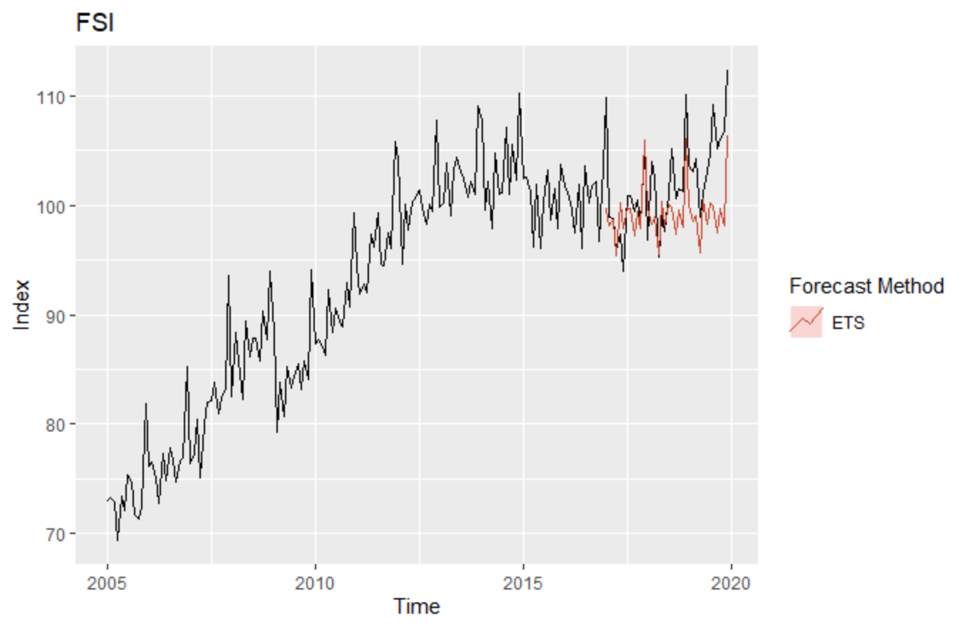

***Fig 4.3 ETS Point Forecasts & Prediction Interval******Fig 4.4 ETS Forecast vs Actual***

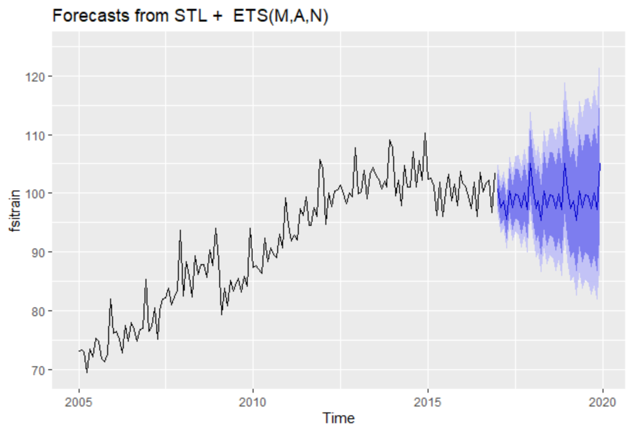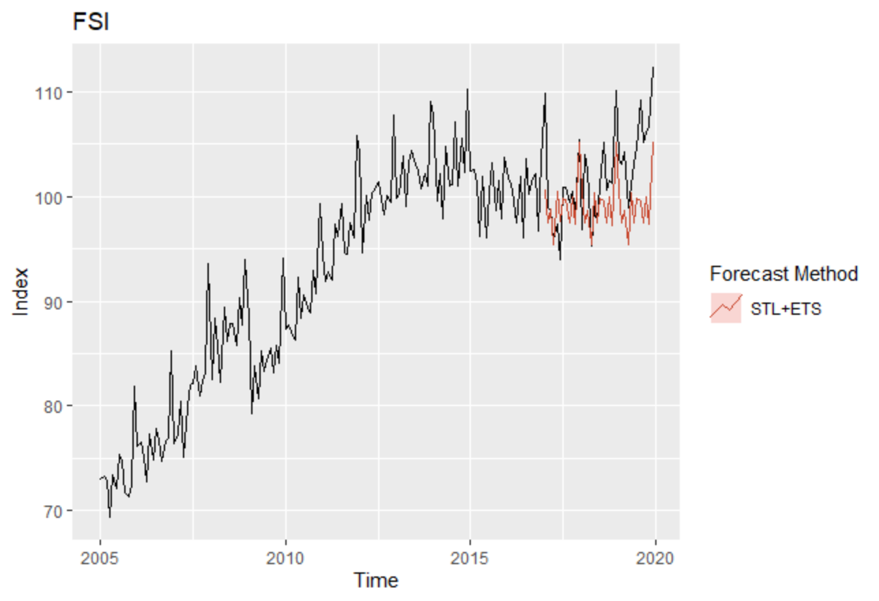

***Fig 4.5 STL-ETS Point Forecasts & Prediction Interval Fig 4.6 STL-ETS Forecast vs Actua***

We compare the forecasts from ETS(M,A,A) and STL+ ETS(M,A,N). ETS seems to be the better model with the lowest forecast error (Table 4.1).



**Table 4.1 ETS vs STL-ETS**

However, looking at the p-value and the ACF plot, it is evident that the errors still contain autocorrelation. Hence, we will consider ARIMA models next.

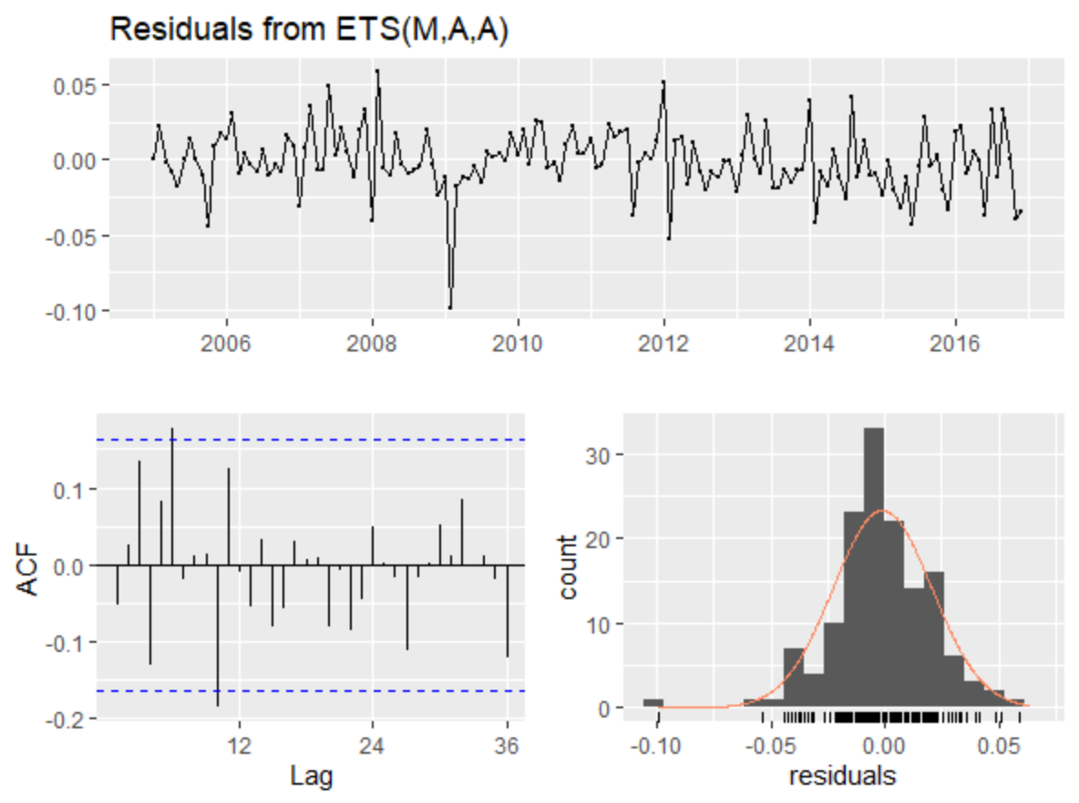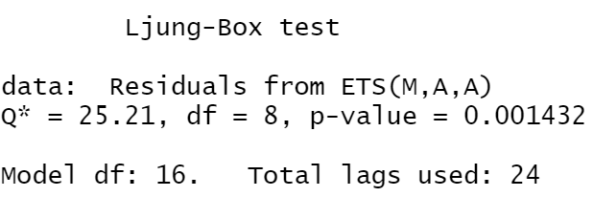

***Fig 4.7 Residuals of ETS(M,A,A)***

Next, we consider S.ARIMA models. Looking at the ACF of FSI (Fig 4.8), the series appears to be non-stationary data as the ACF decreases slowly. We also check the stationarity of the data by using the unit root tests. The large p-value from ADF test confirms that the null hypothesis of non-stationarity cannot be rejected.

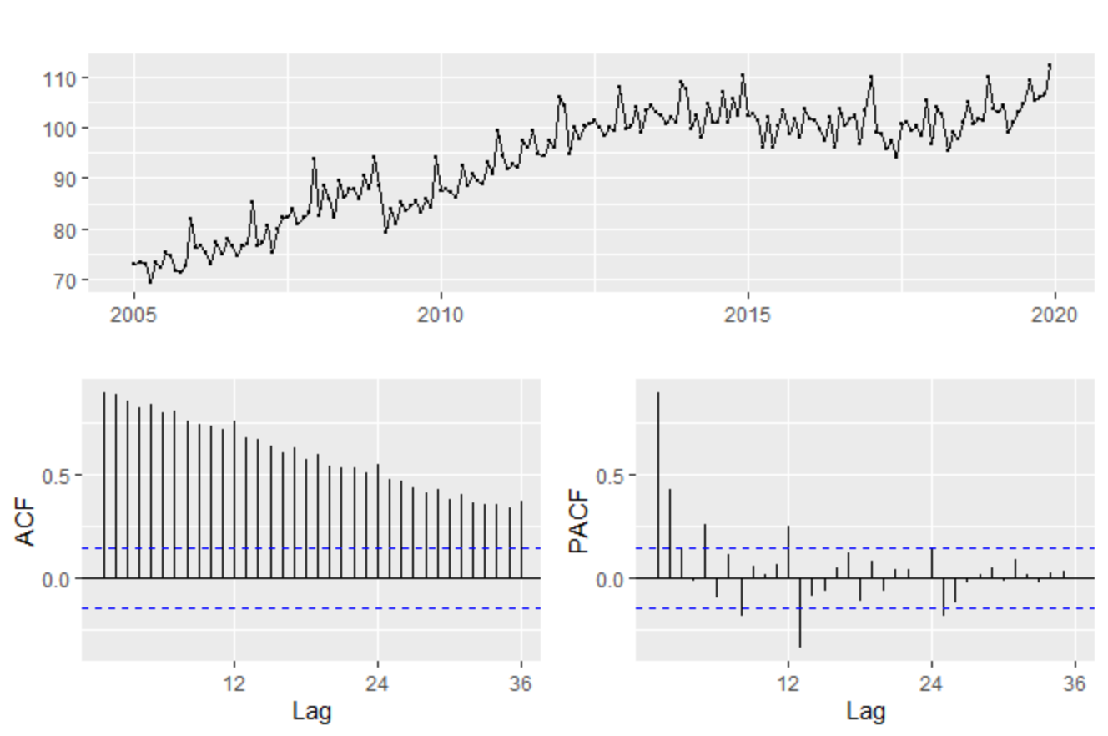

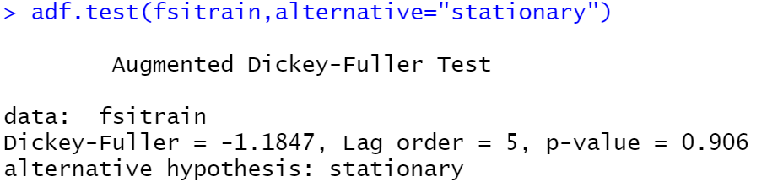

***Fig 4.8 ACF & PACF Plots of FSI***

We will apply seasonal differencing since it displays a strong seasonal pattern. However, it is insufficient to make the series stationary, as shown by the ADF test below:

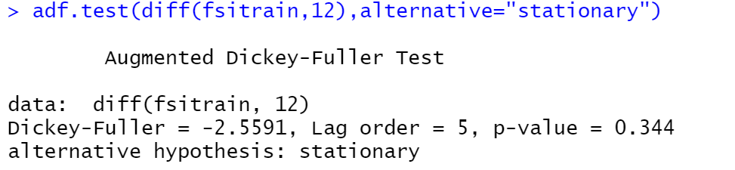

***Fig 4.9 ADF Test for Seasonal Differencing***

Hence, we consider first differencing after a seasonal difference.

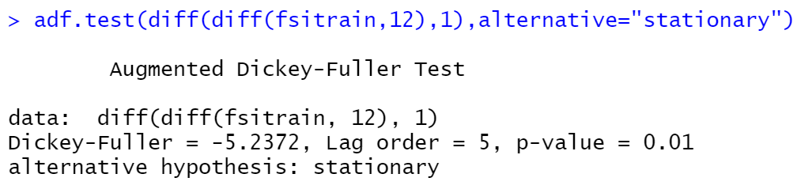

***Fig 4.10 ADF Test for Double Differencing***

From the test, we can tell that the p-value is small, and we can reject the null hypothesis of non-stationarity to conclude that the series is now stationary.

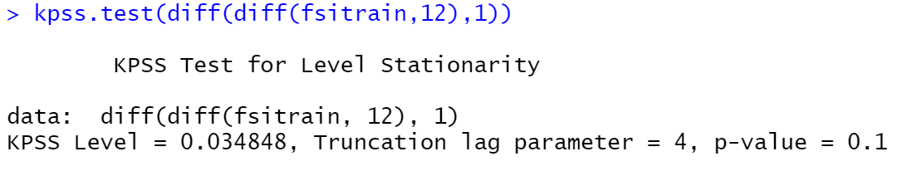

***Fig 4.11 KPSS Test for Double Differencing***

We obtain a similar result from doing the KPSS test, where the p-value is large and we cannot reject the null hypothesis of stationarity at 10% level of significance. Hence, we take a double differencing to ensure stationarity.

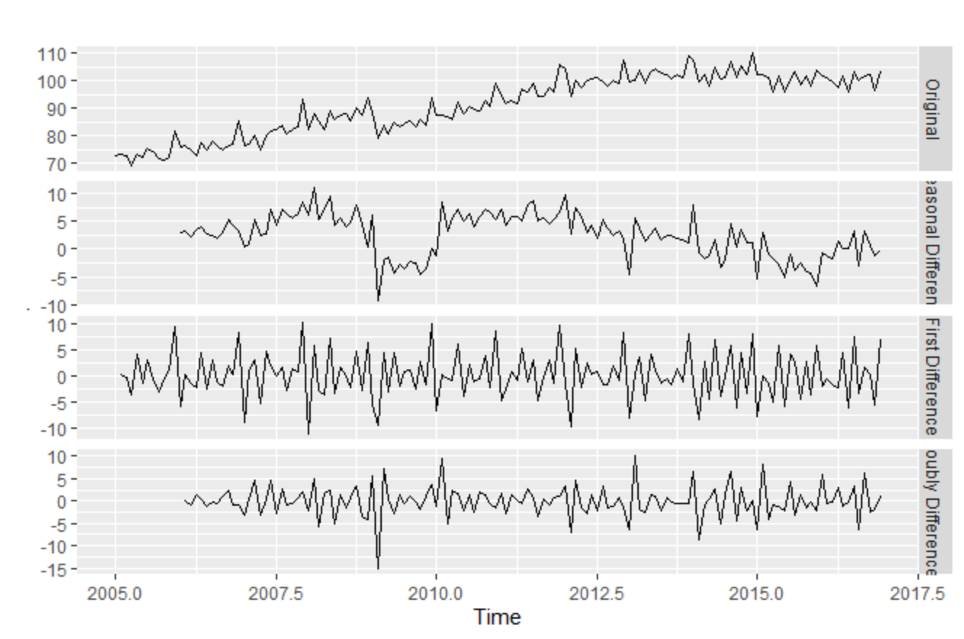

***Fig 4.12 Plots of transformed data***

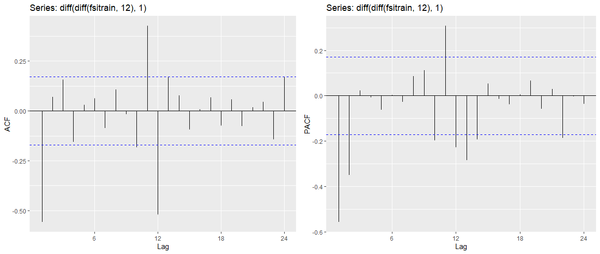

***Fig 4.13 ACF & PACF plots of transformed data***

We then look at the ACF and PACF plots of the differenced data. From the ACF plot, the significant spikes at lag 12 suggest a seasonal MA(1) component. The significant spike at lag 1 suggests a non-seasonal MA(1) component. Alternatively, if we look at the PACF plot, the significant spikes at lag 12 suggest a seasonal AR(1) component. The significant spikes at lags 1 and 2 suggest a non-seasonal AR(2) component. As such, we consider the following models :

* ARIMA(1,1,0)(0,1,1)[12]
* ARIMA(1,1,1)(0,1,1)[12]
* ARIMA(2,1,0)(0,1,1)[12]
* ARIMA(2,1,1)(0,1,1)[12]
* ARIMA(2,1,0)(0,1,2)[12]

We also try the auto.arima() function, which provides us with the model ARIMA(2,1,0)(0,1,1)[12].

We look at the errors of the selected ARIMA models.

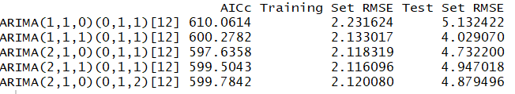

***Table 4.2 ARIMA Errors***

The model with the lowest AICc is ARIMA(2,1,0)(0,1,1)[12], which is the one selected by auto.arima(). However, as our forecast criteria goes, we will be selecting ARIMA(1,1,1)(0,1,1)[12] as the best ARIMA model since it has the lowest forecast RMSE. The respective measurement and equations of the model are as follows :

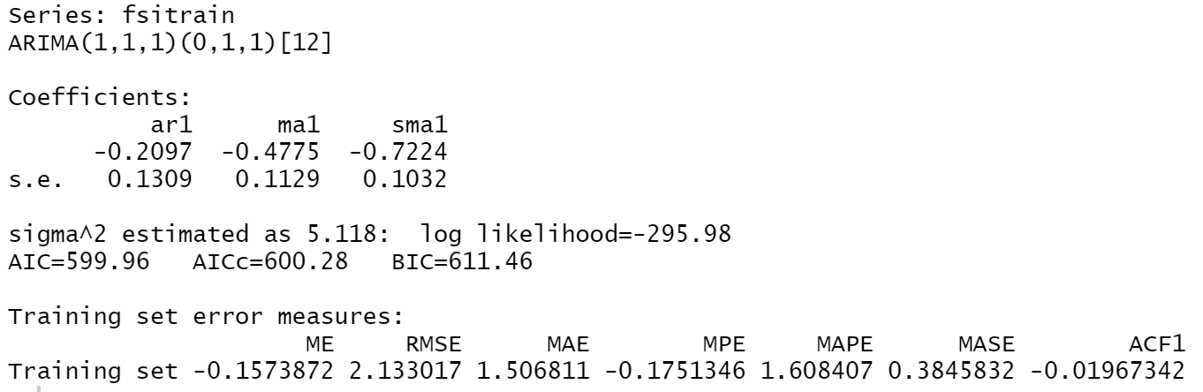

$$\left(1+0.210B\right)\left(1-B\right)\left(1-B^{12}\right)y_{t}=(1-0.478B)\left(1-0.722B^{12}\right)e_{t}$$

***Fig 4.14 Summary of ARIMA Model***

**STL-ARIMA**

Next, we consider the STL-ARIMA model. We looked at the ACF and PACF plots of the differenced seasonally-adjusted data. From the PACF plot, we see 2 significant spikes at lag 1 and lag 2, suggesting an AR(2) model. Alternatively, from the ACF plot, we see a significant spike at lag 1, suggesting a MA(1) model.

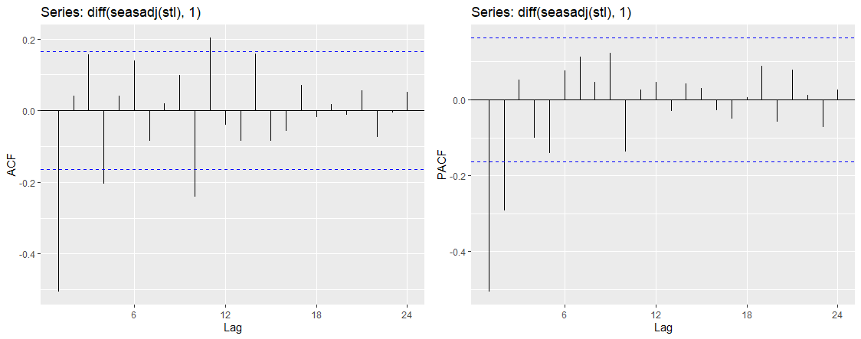

***Fig 4.15 ACF & PACF plots***

Using auto.arima, we obtain STL-ARIMA(2,1,0) with drift.

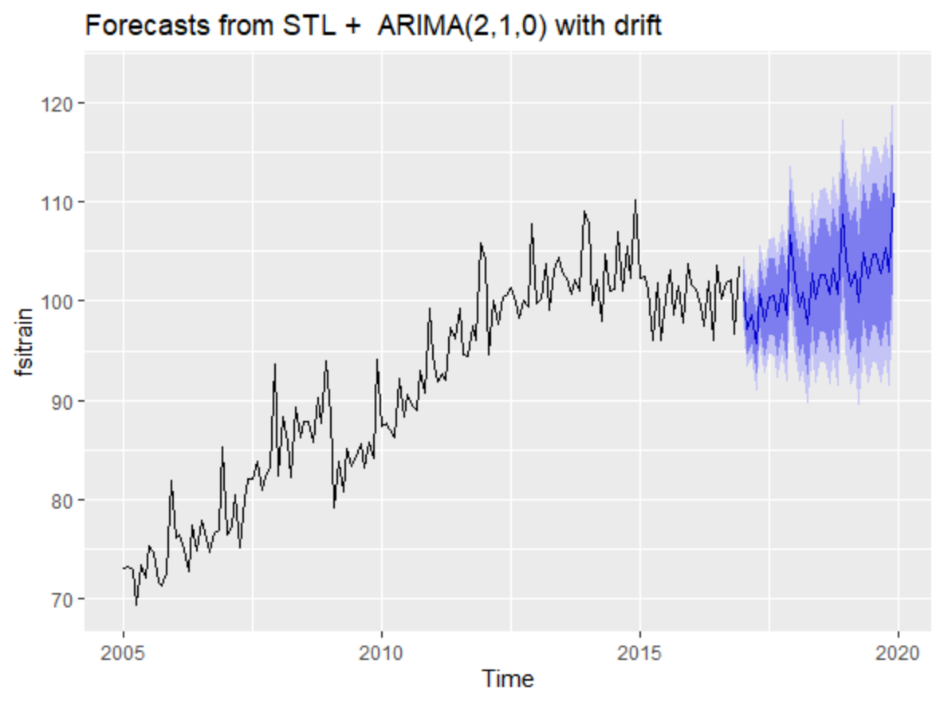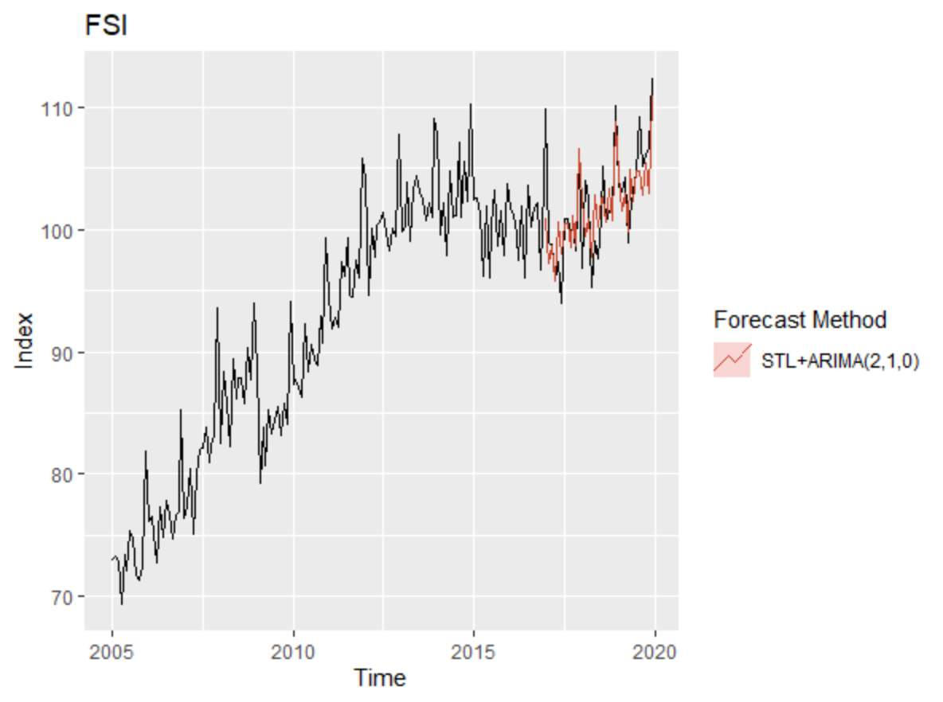

***Fig 4.16 STL-ARIMA(2,1,0)Forecasts Fig 4.17 STL-ARIMA(2,1,0)Forecast vs Actual***

We also consider the case for ARIMA(0,1,1).

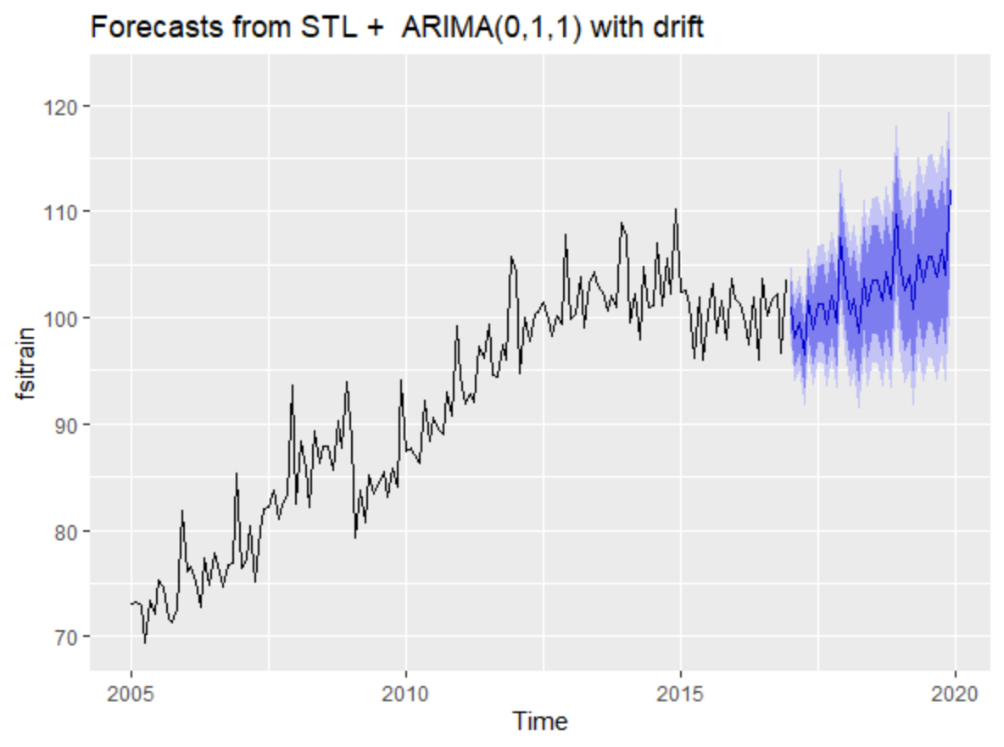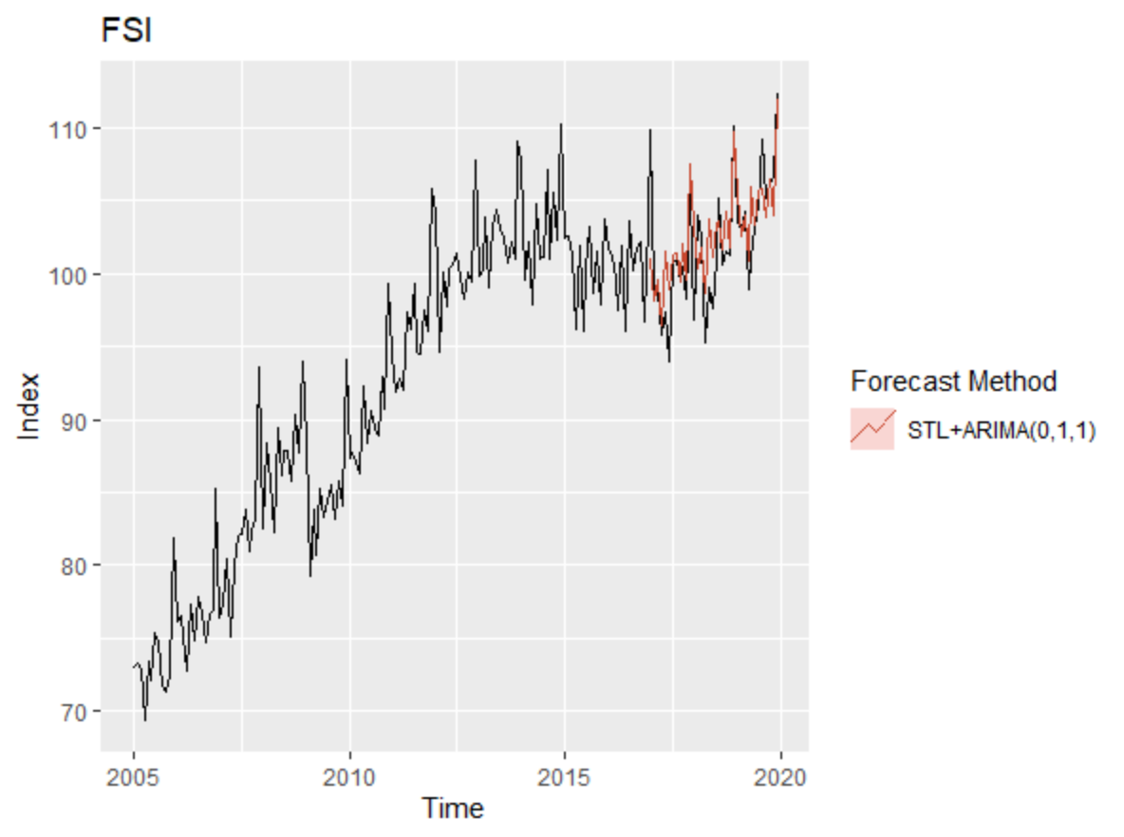

***Fig 4.18 STL-ARIMA(0,1,1) Forecasts Fig 4.19 STL-ARIMA(0,1,1) Forecast vs Actual***

Looking at the forecast error, we can see that the STL-ARIMA models has significantly lower RMSE than S.ARIMA models, perhaps due to the presence of a drift. Since STL-ARIMA(2,1,0) with drift produces the lowest forecast error in the test set, we conclude it to be our best model for forecasting FSI in this section.



**Table 4.3 STL-ARIMA vs ARIMA Errors**

Lastly, we proceed to check the residuals of the selected model. Looking at the high p-value, we are not able reject the null hypothesis of no autocorrelation, even at 10% significance level. Hence, in this section, we will be concluding with **STL-ARIMA(2,1,0) with drift** as the best model for forecasting FSI thus far.

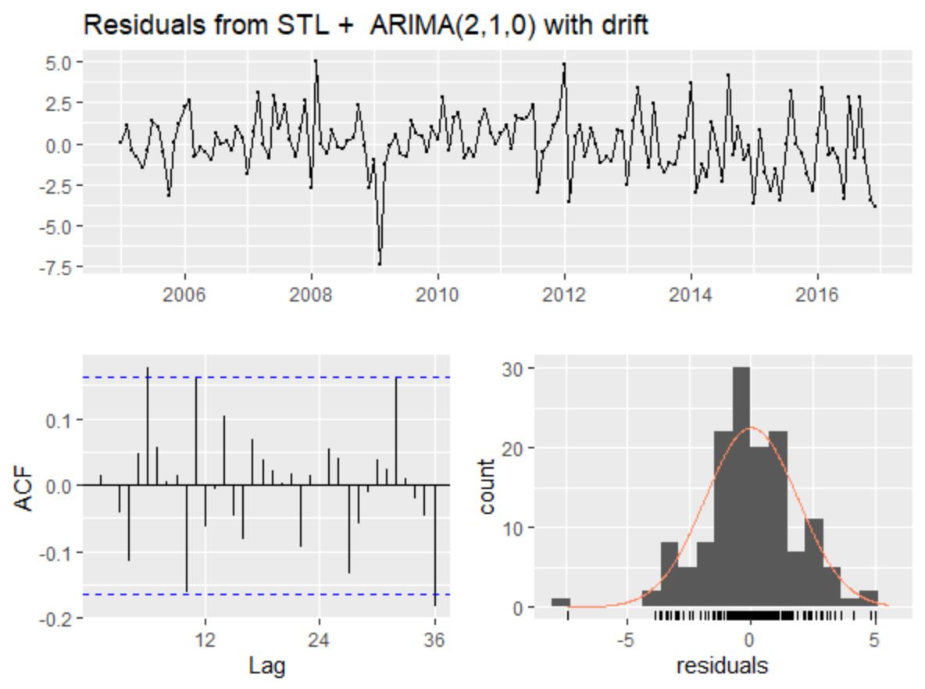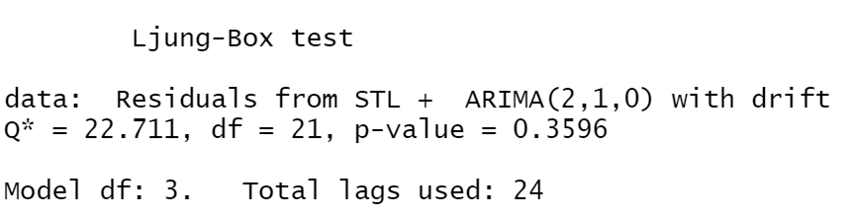

***Fig 4.20 STL-ARIMA Residuals***

**SECTION 5 :** REGRESSION

**Multiple Regression Model**

To build a predictive model, we explore possible predictor variables that are useful to explain the variation in FSI. From our research on the Food & Beverage Services sector, there are multiple factors, ranging from demand to supply-side, that drive the FSI. However, while there are a myriad of factors influencing the level of FSI, there is limited data available in the public sphere that could be useful to explain the monthly series of FSI. As such, we propose the following predictor variables obtained from SingStat (Refer to Table 5.1).

* Retail Sales Index, in Chained Volume Terms – “rsi”
* Total International Visitor Arrivals (values per 10,000) – “tourism”
* Consumer Price Index – “cpi”
* Index of Industrial Production – “ipi”
* Unit Labour Cost Index – “ulc”

To prevent a spurious regression, it is important to ensure that the time-series needs to be stationary. By looking at the plot (Fig 5.1), it is obvious that the variables are not stationary. As noted in the previous section, we take the first seasonal difference followed by the first non-seasonal difference to ensure stationarity of FSI. To retain the form of the relationship between its predictor variables, we apply the same differencing to the predictor variables. After taking the difference, they appear to be stationary and they are ready to be regressed.

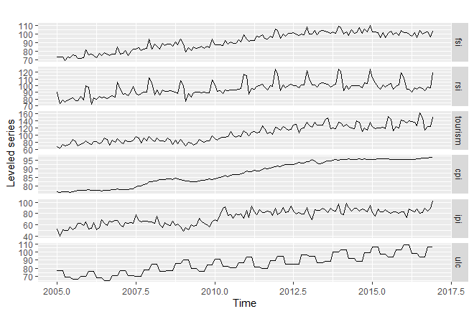

***Fig 5.1 Plots of variables***

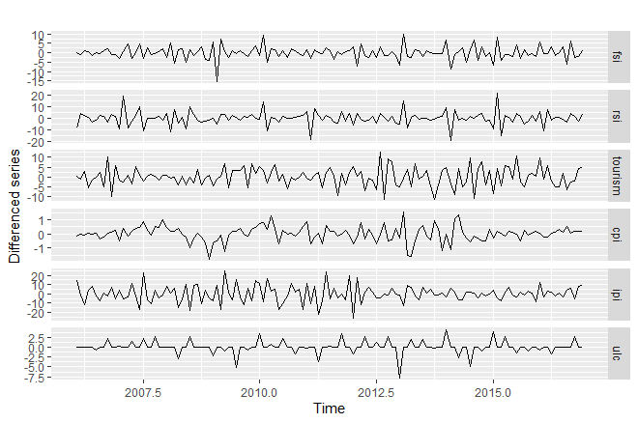

***Fig 5.2 Plots of differenced variables***

After ensuring stationarity of the variables, we use the GGally::ggpairs function to better understand the interaction between the variables and check for the issue of multicollinearity. We observe a moderate correlation of FSI between “rsi”, “tourism”, “cpi” and “ipi” but a weak correlation with “ulc”. The weak correlation with “ulc” could be due to the inaccurate transformation of quarterly to monthly series. Also, “fsi” and “ipi” happens to have a negative correlation which is against our initial hypothesis. As we are interested in the forecasting of “fsi” instead of finding causal inferences, we decide not to investigate further.

Lastly, it is observed that the bivariate correlation between individual predictor variables is relatively low. By avoiding the issue of multicollinearity in our regression model, this helps to improve the accuracy of our forecast.

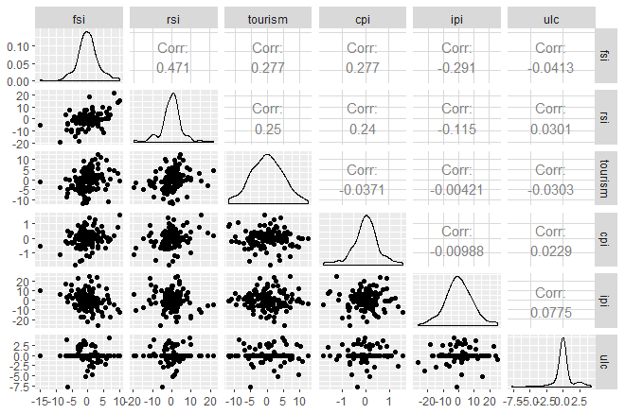

***Fig 5.3 Correlation Matrix***

|  |  |  |
| --- | --- | --- |
| Predictor Variable | Description + Rationale | Object name (for reference) |
| *Retail Sales Index, (2017 = 100), In Chained Volume Terms, (SSIC 2015 Version 2018), Monthly -* ***‘Total (Excluding Motor Vehicles)’*** | The Retail Sales Index (RSI) measures the short-term performance of the retail trade based on the sales records of retail trade. By taking the chained volume to remove its price effect, the total output in the retail sector acts as a good proxy for consumer traffic in retail outlets as food services are increasingly located in shopping malls. | “rsi” |
| International Visitor Arrivals By Inbound Tourism Markets, Monthly - ‘**Total International Visitor Arrivals By Inbound Tourism Markets**’ (**Scale per 10,000 visitors)** | The monthly visitor of arrivals tracks the number of tourists from all countries arriving to Singapore. As the tourism sector contributes 4 per cent to Singapore’s GDP in 2019 (STB,2019), this indicator can help to explain the demand of F&B services in Singapore. | “tourism” |
| *Consumer Price Index (CPI), 2019 As Base Year, Monthly -* ***‘All items less accommodation’*** | The CPI measures the average price changes in a fixed basketof goods and services commonly purchased by resident household overtime. As a measure of consumer price inflation, this signals the strength of the economy that can help to explain the demand of F&B services in Singapore. | “cpi” |
| Index Of Industrial Production (Base Year 2019 = 100), Monthly -  ***‘Total’*** | The IPI measures the real production output of manufacturing, mining, and utilities. As the industrial sector accounts for approximately a quarter of Singapore’s GDP, this signals the strength of the economy that can help to explain the demand of F&B services in Singapore. | “ipi” |
| *Unit Labour Cost Index (2015 = 100), Quarterly* ***- ‘Unit Labour Cost Of Accommodation & Food Services’*** *;*  **(As the monthly index is not available, we transform the quarterly index into a monthly series by repeating each quarter into 3 months)** | The ULC index measures the average cost of labour per unit of output and is computed as Total Labour Cost per unit of real Gross Value Added in the corresponding industry. With the labour crunch in the Singapore’s Food and Beverage sector, many restaurants are finding difficulties to maintain their operations and might be encouraged to raise the salaries of their employees to retain the talent pool. | “ulc” |

***Table 5.1 Description of Predictor Variable***

Since there are 5 predictor variables to be regressed on our dependent variable, FSI, there are a total of 2^5 = 32 different models to be tested on. The models were fitted, and the results are summarised in Table 5.2, sorted by increasing AICc.

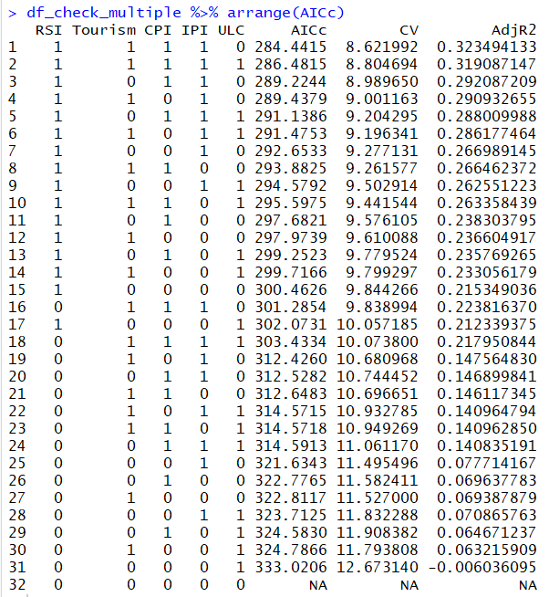

***Table 5.2 Comparison of Multiple Regression Models***

The model that produces the lowest AICc is the model with “rsi”, “tourism”, “cpi” & “ipi” as predictor variables. This model also happens to produce the lowest CV and the highest adjusted R2 values. As such, we proceed to take a deeper look into this model.

A summary shows that all the predictor variables are significant at the 5% significance level. The coefficient of IPI is however negative, against what we expected. To check for multicollinearity, we apply Variance Inflation Factor (VIF) on the model and low VIF confirms the lack of multicollinearity.

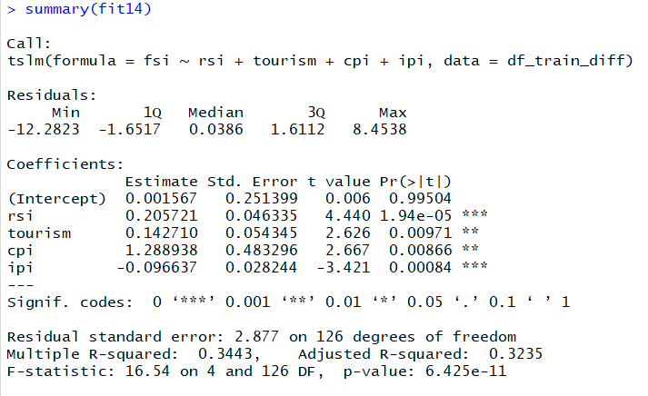

***Fig 5.4 Summary of Multiple Regression***

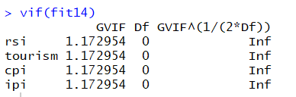

***Fig 5.5 VIF test***

We then proceed to investigate if the residuals resemble white noise. The residual plot shows significant autocorrelation, failing the Ljung-Box test at 5% level of significance with p-value less than 0.05. It is observed that there are significant spikes at lag 1 and lag 12 and lag 24, suggesting a possible ARMA error that follows a non-seasonal MA(1) and a seasonal MA(1) process. The histogram of the residuals also shows that the residuals do not follow a normal distribution.

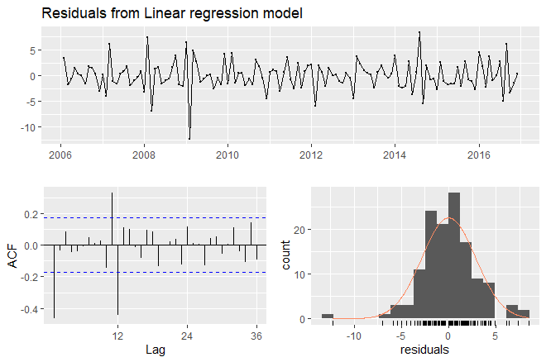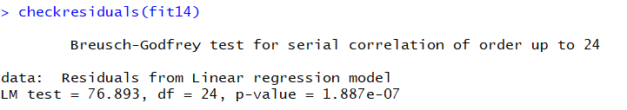

***Fig 5.6 Residuals of Multiple Regression Model***

As the errors do not appear to be white noise, there is information left in the residuals which should be used to compute the forecast. Hence, we move on to consider dynamic regression to introduce the ARMA process to the errors.

**Dynamic Regression Model**

We fit a dynamic regression model using the auto.arima() command to allow the errors to be autocorrelated, i.e. the errors follow an ARIMA model. We specify a first-order non-seasonal difference (d=1) and a first-order seasonal difference (D=1) to ensure that all the variables are stationary. The models were fitted, and the results are summarised in Table 5.3, sorted by increasing AICc. The corresponding RMSE and Ljung-Box test results for autocorrelation are also displayed.

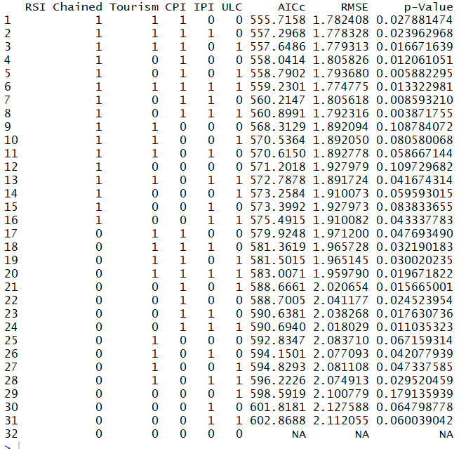

***Table 5.3 Comparison of Dynamic Regression Models***

The model that produces the lowest AICc is the model with “rsi_chained”, “tourism” & “cpi” as predictor variables, dropping “ipi” from the model selected by the multiple regression. While including “ipi” and/or “ulc” helps to lower the residuals as denoted by RMSE, the changes are not significant. Since we need to take the prediction of our predictor variables into consideration for ex-ante forecasts of FSI, we have decided to drop “ipi” to reduce the uncertainty in the forecast of the predictors.

**

***Fig 5.7 Candidate Model***

The candidate model chosen by AICc has RMSE value of 1.78 in the training set which is lower than that of models selected in the previous sections. We then proceed to investigate further on this model.

A summary (Fig 5.8) shows that the coefficient of the predictor variables is positive, and the regression error follows an ARIMA process of (0,1,1)(0,1,1)[12] as predicted above. The MA coefficients for both seasonal and non-seasonal components are negative, suggesting that the errors from the regression model is negatively correlated with the random shocks in the preceding periods.

The respective equations for the regression and ARIMA errors are as follows :

$${fsi}_{t}=0.2898{rsi}_{t}+ 0.0647{tourism}_{t}+ 1.163{CPI}_{t}+ η_{t}$$

$$\left(1-B\right)\left(1-B^{12}\right)η_{t}=(1-0.8675B)(1-0.6202B^{12}) ε_{t}$$

$$ε_{t} \sim NID(0, 3.631)$$

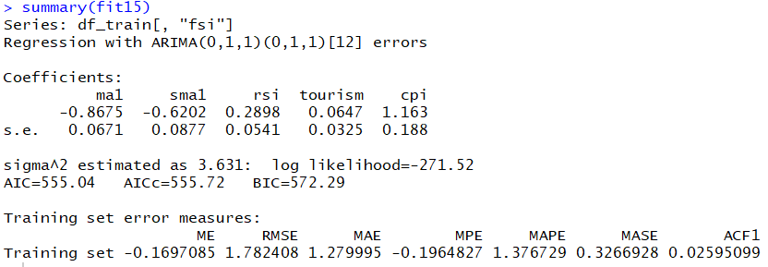

***Fig 5.8 Summary of Dynamic Regression Model***

We then proceed to check if the ARIMA error indeed resembles white noise. Although some autocorrelation is removed, the p-value from Ljung-Box test remains low for the null hypothesis of no autocorrelation to be rejected even at the 5% significance level. As such, the model still has some significant autocorrelation in the residuals. The histogram plot of the residuals also shows that the residuals are not normally distributed. significantly improved compared to that in the multiple regression model. Hence, this will affect the coverage of prediction intervals.

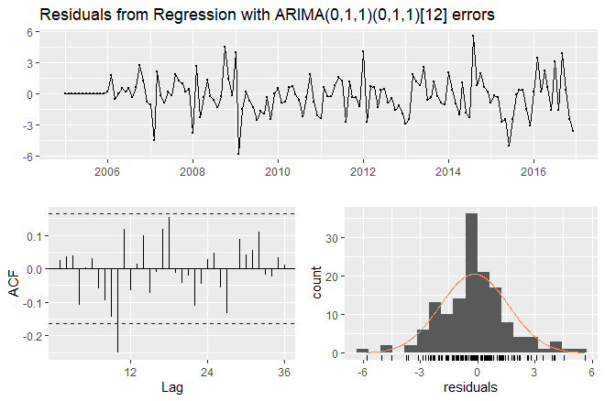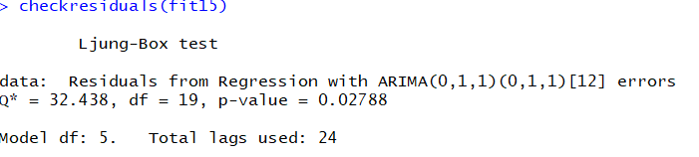

***Fig 5.9 Residuals of Dynamic Regression Model***

To improve the model by lowering the autocorrelation, we specify the seasonal differencing, D, to 0, as the previous models tested have very low p-Value. We then iterate this specification to all the candidate models and sort by increasing AICc. The model chosen by AICc points to the same model as previously fitted.

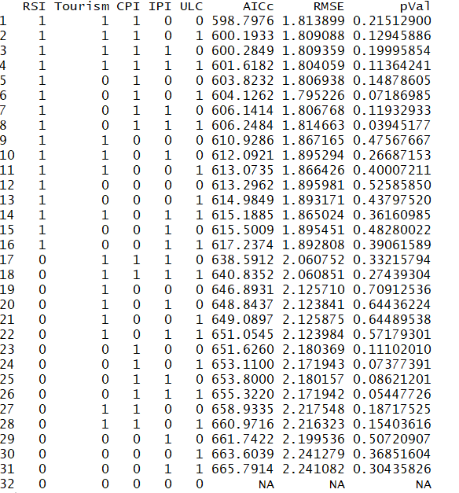

***Table 5.4 Comparison of Dynamic Regression Models with D=0***

We then proceed to take a closer look on the model chosen by AICc when we specify D=0.

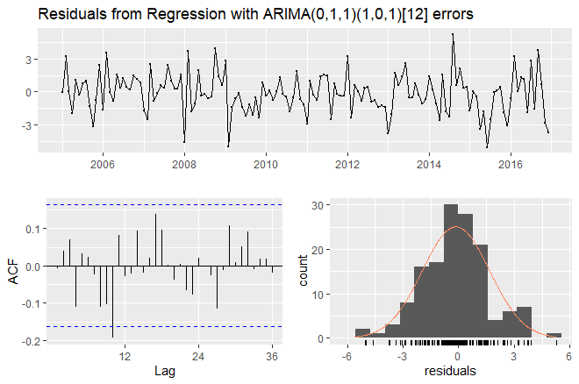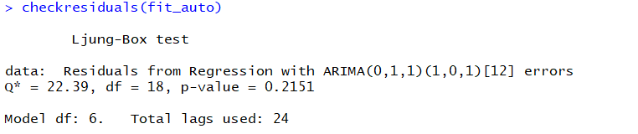

***Fig 5.10 Residuals of Dynamic Regression Model with D=0***

The model selected by AICc when specified D=0 returns a model with ARIMA(0,1,1)(1,0,1)[12] errors. This also happens to be the model chosen by auto.arima() without any constraints. Using the Ljung-Box test for autocorrelation, we cannot reject the null hypothesis of no autocorrelation, even at 10% significance level.

Using RMSE as a criterion, we evaluate the two models by fitting on the training set to forecast into the test set. While the p-value shows an improvement for the model with ARIMA(0,1,1)(1,0,1)[12] errors, it leads to a poorer fit as both RMSE in the training (1.81 vs 1.78) and test set (3.34 vs 3.27) exceed that of the previously fit model, i.e. ARIMA(0,1,1)(0,1,1)[12].



***Table 5.5 Comparison of the 2 Models***

Hence, with all these reasons combined, our group concluded that the best model for forecasting in this section is the dynamic regression model with ARIMA (0,1,1)(0,1,1)[12] using “rsi”, “tourism” & “cpi” as predictor variables error. Lastly, it is observed that the prediction interval is also narrower than those for the model developed in earlier sections as we are now able to explain some of the variation in the data using the predictor variables.

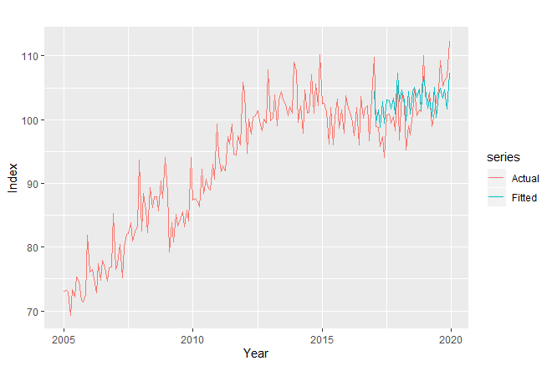

***Fig 5.11 Actual vs Fitted***

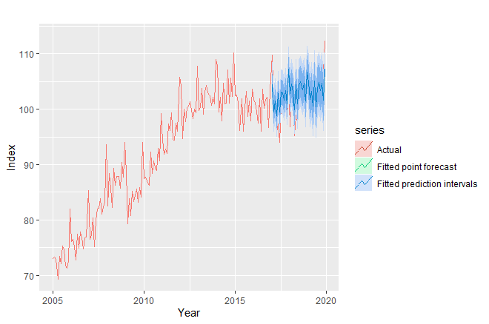

***Fig 5.12 Actual vs Fitted Prediction Intervals***

**SECTION 6 :** MODEL SELECTION & FORECASTING

We have previously fitted various models using data from Jan 2005 to Dec 2016, and forecasted the FSI for Jan 2017 to Dec 2019. In this section, we first evaluate the fitted models by comparing the forecast RMSE of the the leading candidates in previous sections, namely the seasonal naive model (benchmark model), STL-ARIMA with drift model, and Dynamic Regression model. In addition, we also compare with the respective combinations of those models by taking the average of the forecasts.

* **Combination 1 -** Combination of seasonal-naive & STL-ARIMA with drift forecasts
* **Combination 2 -** Combination of seasonal-naive & Dynamic Regression forecasts
* **Combination 3 -** Combination of STL-ARIMA with drift & Dynamic Regression forecasts
* **Combination 4 -** Combination of seasonal-naive, STL-ARIMA with drift & Dynamic Regression forecasts

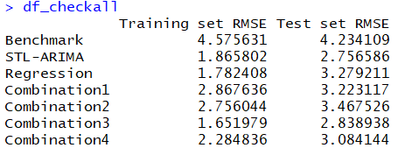

***Table 6.1 RMSE Comparison***

Referring to Table 6.1**,** both the STL-ARIMA with drift and Dynamic Regression model perform better than the seasonal-naive benchmark model with lower RMSE values. While the Dynamic Regression model has the lowest RMSE in the training set, the STL-ARIMA model with drift yields the lowest RMSE in the test set. Despite taking various combinations, STL-ARIMA model with drift still produces lower RMSE in the test set than that of Combination 3. Using RMSE of the test set as a criterion for evaluating the best model, we then decide to select STL-ARIMA with drift for forecasting. into our FSI dataset from January 2005 to February 2020.

We fit the model using STL-ARIMA (2,1,0) with drift for 12-months ahead pre-COVID19 ex-ante forecast. We also use bootstrapping to estimate our forecast errors by adding the bootstrap argument to our forecasting function as the residuals are not normally distributed.

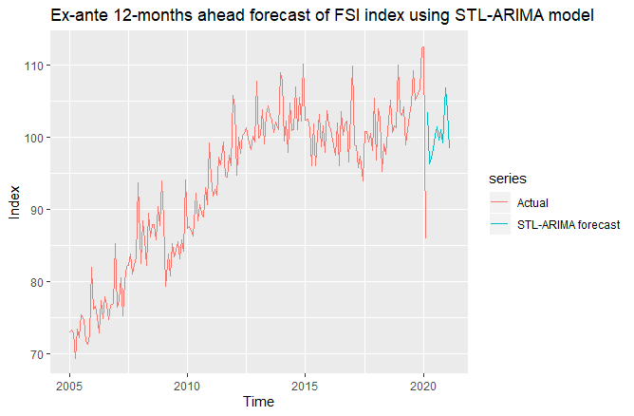

***Fig 6.1 STL-ARIMA Ex-ante Forecast***

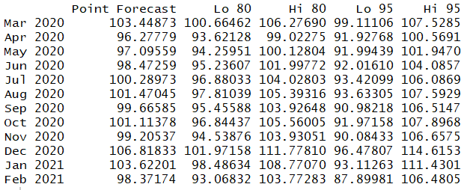

***Table 6.2 STL-ARIMA Ex-ante Forecast Values***

However, considering the current COVID pandemic, we observe a downfall in predictor variables. The March 2020 values of ‘tourism’ can now be observed on the STB website. Tourism numbers have decreased by over 50% in February, and further decreased by another 50% in March. As predicted by the Dynamic Regression model, a large fall in “tourism” would, on average, decrease the estimate of FSI as they are positively correlated.

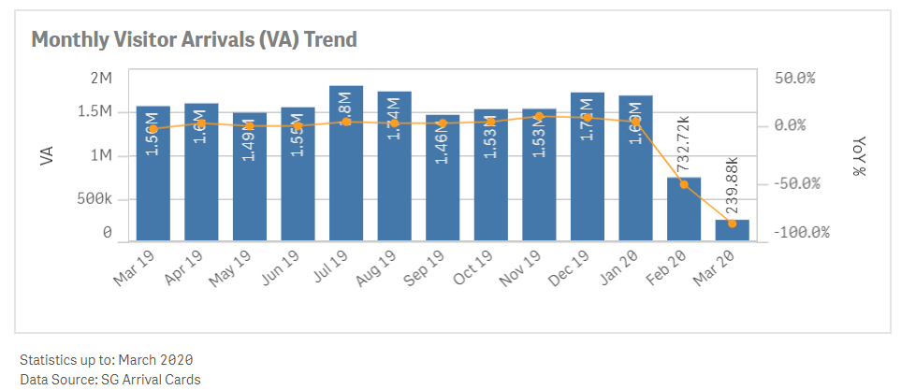

***Fig 6.2 Tourism Figures from Singapore Tourism Board***

To further illustrate the incapability of STL-ARIMA in capturing the extent, we compare the fitted values when fitting STL-ARIMA and Dynamic Regression models on FSI index from January 2005 to February 2020.

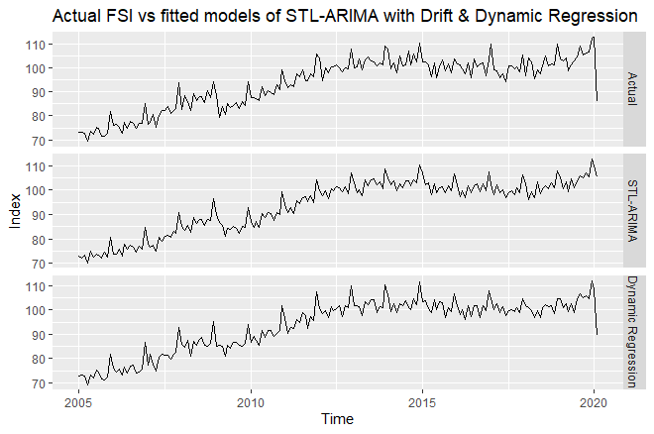

***Fig 6.3 Comparison of STL-ARIMA vs Dynamic Regression Model***

Looking at Feb 2020 figures, the actual FSI value is reported to fall from 112 to 85. Our Dynamic Regression model captures the event with an estimate of 90 in Feb 2020, as compared to an estimate of 105 using STL-ARIMA with drift. Clearly, the STL-ARIMA model with drift would be unreliable in our short-term forecast. Hence, we will use the Dynamic Regression model instead to reflect the current events. As noted above, the ‘best’ dynamic regression model chosen may still have autocorrelation and therefore prediction intervals will be inaccurate.

As it is highly uncertain when the world economy would recover from COVID19 immediately, we form 2 different scenarios to help in our 12-month-ahead forecast. To get a better view of how long Singapore’s economy would be affected by a pandemic, we take a quick look at our predictor variables during the SARS period in 2003-2004. SARS first came to Singapore in March 2003 and was declared cleared in March 2005. During this period, we noticed a significant dip in “tourism” figures, as well as a slight dip in “rsi” and “cpi”. It took about 4-6 months before the variables returned to their normal level.

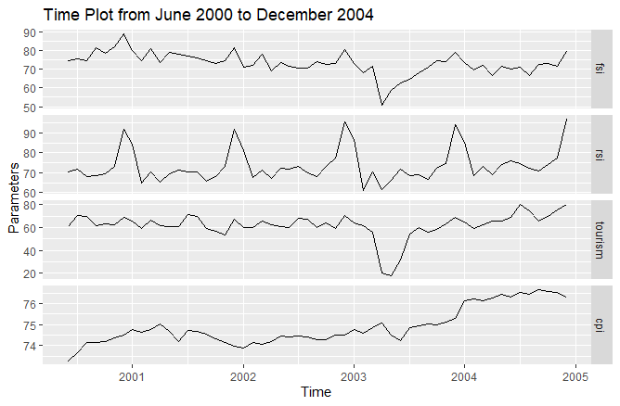

***Fig 6.4 Effect of SARS***

Since the values of “tourism” & “cpi” for March are already known, we can perform an ex-post forecast for FSI in March. Since the “rsi” index for March 2020 is not known yet, we take the naive forecast using stlf(method=”naive”) command to capture the effect of COVID19 on “rsi” after taking seasonality into account. Our forecast for March 2020 gives us a point estimate of FSI = 79.0. In April, we know that airports are closed with the global lockdown situation, thereby expecting almost no visitors; i.e. “tourism” = 0. The grave impact on the predictor variables are likely to persist until June. Due to the uncertainty in the COVID19 situation, we form 2 likely scenarios for our forecasts of predictor variables. To account for the asymmetry of risk across the scenarios, our forecast will take a probability-weighted average of the 2 scenarios (Caldwell. Andersen, 2020).

**Grim : COVID19 situation persists leading to more containment measures and hence a longer recovery period required (For the next 12 months)**

When forecasting given the grim scenario, we take a naive forecast and adjust it by the seasonality using stlf(method = “naive”) command for the predictor variables, which are then fitted into the Dynamic Regression model to forecast the FSI. The forecasts remain low for the next 12 months. Prediction intervals are also approximated by using bootstrapping method.

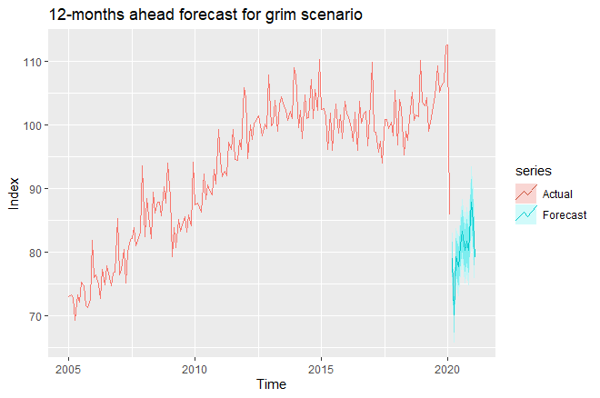

***Fig 6.5 Grim scenario Forecast***

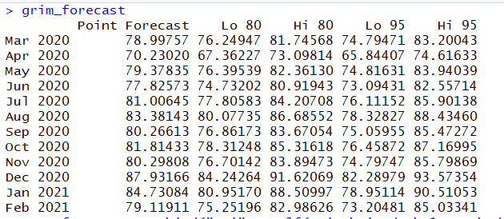

***Table 6.3 Grim scenario Point Forecasts & Prediction Interval***

**Good : A successful containment measure leads to businesses largely reopening in June and economic recovery begins shortly.**

In this scenario where normal economic activity resumed from June onwards, we append the first 3 months of grim forecast to the subsequent 9 months forecasted using STL-ARIMA with drift model to match the pre-COVID19 forecast. A steep increase is observed from May-June.

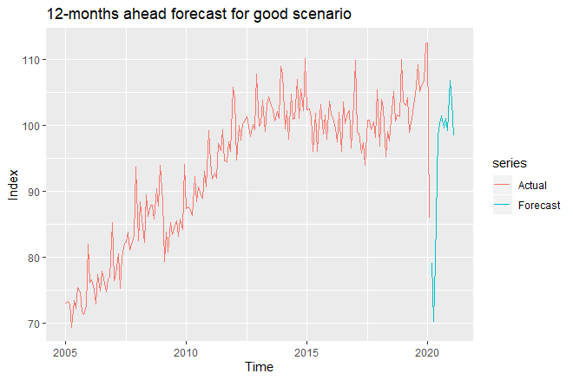

***Fig 6.6 Good scenario Forecast***

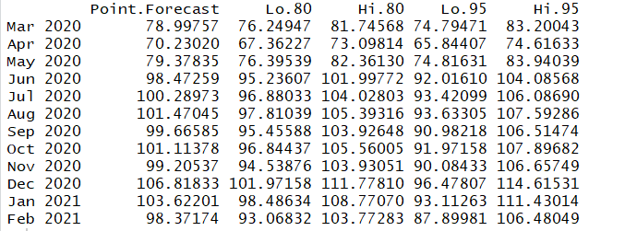

***Table 6.4 Good scenario Point Forecast & Prediction Interval***

Lastly, we take a weighted average to reflect the expected point forecast of the two given scenarios. Learning from SARS, we expect a longer recovery. Hence, we assign a weight of 0.7 for grim scenario and 0.3 for good scenario. Our forecast illustrates an expected downfall in FSI for the next 3 months (lowest in April) and gradually increases from June onwards.

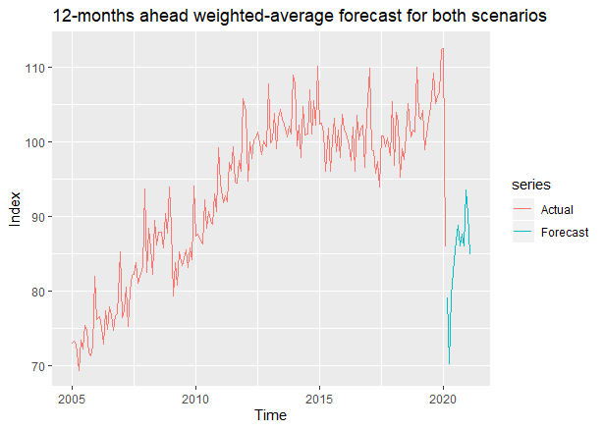

***Fig 6.8 Probability-Weighted Average Point Forecasts***

**SECTION 8 :**

CONCLUSION

In our approach to forecast the FSI for Mar 2020 to Feb 2021, we have explored various types of models – from naïve to regression models. As the onset of COVID19 during the beginning of the year is a unique period and unexpected event, we have decided to fit the models using data from January 2005 to December 2016 and use January 2017 to December 2019 as our test set.

Using forecast RMSE as our criterion to select the best model, we concluded that STL-ARIMA (2,1,0) with drift leads to the lowest test-set RMSE. However, when we used this model to forecast the FSI for Mar 2020 onwards, the forecast produced by this model fails to account for the drastic economic impact that COVID19 yields. Hence, we turn to our next best alternative - Dynamic Regression model with ARIMA errors (0,1,1)(0,1,1)[12]. Although this model produces more accurate point forecasts, we noted that there may still be significant autocorrelations as the model fails the Ljung-Box test. Hence, the prediction intervals might not be accurate.

Due to the uncertainty of COVID19, we use scenario forecasting to come up with 2 separate forecasts of a grim and good scenario and conclude the section by taking a probability weighted-average of the point forecasts to reflect our group’s sentiments on the impact of COVID19 with reference to the SARS pandemic in 2003.

In conclusion, the forecast model could still be improved if more publicly accessible datasets, that could explain the movements in FSI, are available in monthly frequency. A more sophisticated model could also be deployed to better capture the interactions between the predictor variables & FSI index, thereby reducing the autocorrelation in the residuals.

Bibliography

**Datasets :**

<https://www.singstat.gov.sg/find-data/search-by-theme/industry/services/latest-data>

<https://www.tablebuilder.singstat.gov.sg/publicfacing/createDataTable.action?refId=17010>

<https://www.tablebuilder.singstat.gov.sg/publicfacing/createDataTable.action?refId=16924>

<https://www.tablebuilder.singstat.gov.sg/publicfacing/createDataTable.action?refId=15518>

<https://www.singstat.gov.sg/find-data/search-by-theme/economy/prices-and-price-indices/latest-data>

<https://www.singstat.gov.sg/find-data/search-by-theme/economy/labour-employment-wages-and-productivity/latest-data>

<https://www.tablebuilder.singstat.gov.sg/publicfacing/createDataTable.action?refId=16862>

<https://www.tablebuilder.singstat.gov.sg/publicfacing/createDataTable.action?refId=16854>

<https://www.tablebuilder.singstat.gov.sg/publicfacing/createDataTable.action?refId=15660>

<https://www.tablebuilder.singstat.gov.sg/publicfacing/createDataTable.action?refId=16082>

[https://www.tablebuilder.singstat.gov.sg/publicfacing/createDataTable.action?refId=1991#](https://www.tablebuilder.singstat.gov.sg/publicfacing/createDataTable.action?refId=1991)

**References :**

Ministry of Manpower (MOM). (2020, March 19). Chart: Employment Level By Industry. Retrieved from <https://stats.mom.gov.sg/Pages/Employment-Distribution-and-Employment-Level-by-Industry.aspx>

Yeo, A., & Tan, D. (2019, October). SingaporeDownstream F&BMass-market F&B set to sizzle. Retrieved from <https://webcache.googleusercontent.com/search?q=cache:f7V76SQvZ0oJ:https://www.dbs.com/aics/pdfController.page?pdfpath=/content/article/pdf/AIO/102019/191022_insights_fnb.pdf+&cd=2&hl=en&ct=clnk&gl=sg>

Ministry of Manpower (MOM). (2014, September 14). Statement on Labour Market Developments. Retrieved from <https://www.mom.gov.sg/newsroom/mom-statements/2014/15-sep-2014---statement-on-labour-market-developments>

Singapore Budget 2013 - Key Budget Initiatives MEASURES FOR BUSINESSES. (2013). Retrieved from <https://www.singaporebudget.gov.sg/budget_2013/key_initiatives/business1.html>

Singapore Tourism Analytics Network (Stan). (n.d.). Retrieved from <https://stan.stb.gov.sg/portal/>

Fuqua School of Business. (2007). Seasonal differencing. Retrieved from <https://faculty.fuqua.duke.edu/~rnau/Decision411_2007/Class10notes.htm>

Caldwell, P., & Andersen, K. (2020, April 1). Coronavirus Update: Long-Term Economic Impact Forecast to Be Less Than 2008 Recession. Retrieved from <https://www.morningstar.com/articles/976107/coronavirus-update-long-term-economic-impact-forecast-to-be-less-than-2008-recession>

1. The latest FSI data published is February 2020 numbers